Zoho Webinar in Zoho CRM
Figma — CRM and Webinar Integration

Contents
- 1. Integration
- 1.1 Who can participate from CRM
- 1.2 Webinar deal attribution
- 2. Webinar list page
- 3. Create webinar
- 3.1 Live webinar
- 3.2 On-demand webinar
- 3.3 New fields
- 4. Scheduled webinar
- 4.1 Send Invite
- 4.2 View registration source
- 4.3 Registration & Attendance Summary
- 4.4 Poll creation
- 4.5 Session Files
- 4.6 Actions
- 5. Completed webinar
- 5.1 Registration & Attendance Summary
- 5.2 Webinar Revenue
- 5.3 Invited related list
- 5.4 Polls
- 5.5 Q&A
- Things we still need to decide
- Appendix A — every field in the create form

Introduction

What is Zoho Webinar
Zoho Webinar is Zoho's webinar product: you schedule a session, people register through a public form, they attend or they don't, and afterwards you have a recording, a set of poll answers and a Q&A transcript. It runs live sessions, on-demand sessions that play a pre-recorded video, and recurring series. Around the session itself sits a set of lifecycle emails — an invitation, a confirmation, up to three reminders, and separate follow-ups for the people who turned up and the people who didn't.
It is a complete product on its own. This document is not about that product. It is about running it from inside Zoho CRM, as a CRM module.

Who uses it
The person this is built for is a sales rep or account executive who is also the CRM admin for the integration — Jay, in the mock. He lives in Zoho CRM all day. He has never used standalone Zoho Webinar and does not want to learn it as a second product.
The range is wider than one persona, though, and the module list in §1.1 is the evidence: the integration ships with thirteen participant modules, from Leads and Contacts through Donors, Volunteers, Students, Alumni, Patients and Subscribers. That is a non-profit running a donor briefing, a university running an alumni session, a clinic running a patient education webinar, and a B2B software company running a product masterclass — all using the same surface.
What they have in common is the purpose: the webinar is a step in a customer relationship that CRM already owns. The audience is already in CRM as records. The outcome — who registered, who attended, what they asked, whether they bought — belongs back on those records.

Why this integration, and what it solves
Zoho Webinar on its own cannot see CRM. That produces four specific costs, and the integration exists to remove them:
- The audience has to be rebuilt. The people you want at the webinar are already
Leads and Contacts. Standalone, you export them to CSV and re-import them into the webinar tool as a fresh list that immediately starts drifting from CRM. → §1.1 and §4.1: invites are sent to CRM records, from the CRM modules you choose.
- The results have to be brought back by hand. Registrations and attendance land in
the webinar tool. Getting them onto the CRM record is another export and another import. → §3.3 and §5.3: registrants can be pushed into CRM, and every invited record carries its own invite status and attendance status.
- Nobody can answer "did the webinar make money?" The cost sits in one place and the
deals sit in another, and no one joins them. → §1.2 and §5.2: a Webinar Cost on the record, an attribution model that splits deal revenue across the webinars that influenced it, and an ROI panel that does the division.
- It is a second product to operate. Different UI, different login, different
conventions. → The whole document: a Zoho Webinar module inside CRM, with CRM's list views, record pages, related lists, mass email and templates.
Sample use case
Jay runs a free masterclass to generate pipeline. He picks 200 Leads and 40 Contacts in CRM and invites them without leaving the module. Registrants who were not already in CRM are pushed in as new Leads. After the session the record shows 30 registered, 15 attended, what each of them asked in Q&A — and that seven deals worth $16,800 closed off the back of it, against a $2,500 cost.

---

1. Integration
The integration is turned on once, by an admin, from the CRM marketplace. Everything in sections 2–5 depends on it being enabled, and two of its settings change what the rest of the product does — which is why they are the two sub-sections here.
Where it starts: Setup → Marketplace → Zoho → the Zoho Meetings card → For webinars › Set up.
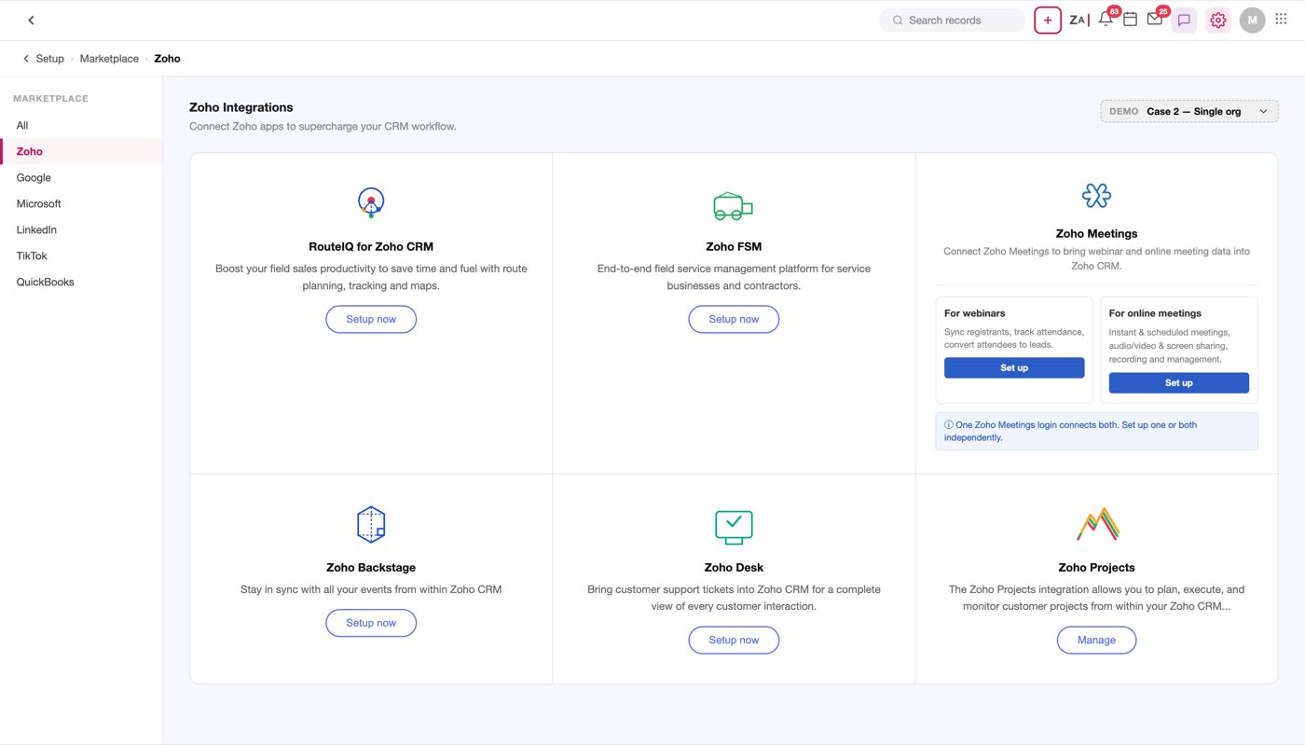
Figure 1 — The Zoho Meetings card in Marketplace ▸ Zoho. "For webinars › Set up" is the entry point
The card checks the account situation before showing anything about the integration. If the user has no Zoho Webinar account, is not an admin, or the trial has expired, a modal says so and the flow stops there. Only a valid account reaches the introduction page.
Note
The check lives at the card, not on the introduction page. That ordering is deliberate — a user who cannot have the integration should not be sold it first. The same branch is also re-checked on the introduction page's Setup button, as a second guard.

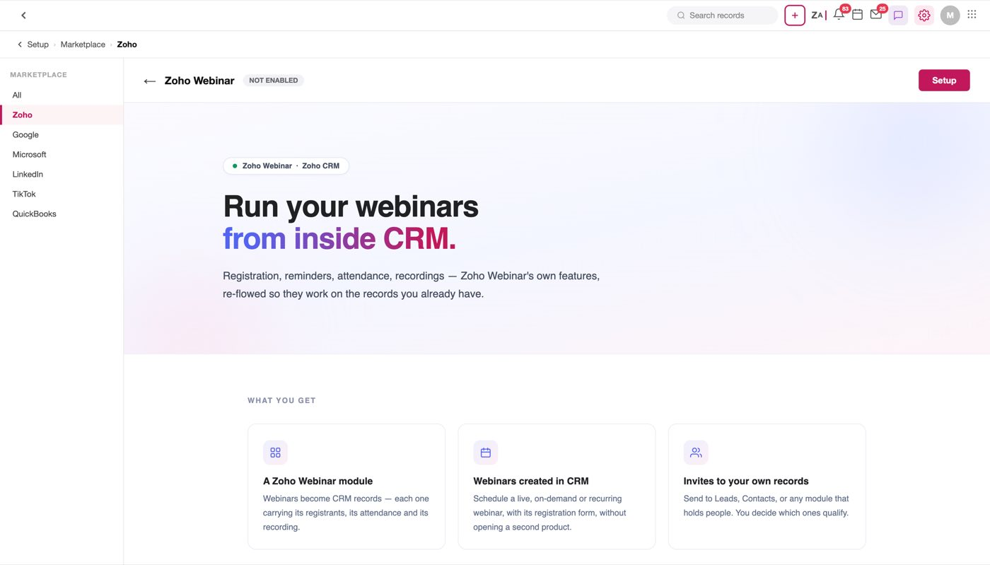
Figure 2 — The introduction page. Enabling happens later — the only action here is Setup, top right
Setup opens a four-step wizard. Each step has Cancel and Next; Cancel abandons setup and returns to the introduction page. The steps accumulate rather than replace each other — an answered step stays on screen so an earlier decision can be re-read while a later one is being made, and only the step being answered shows its buttons.
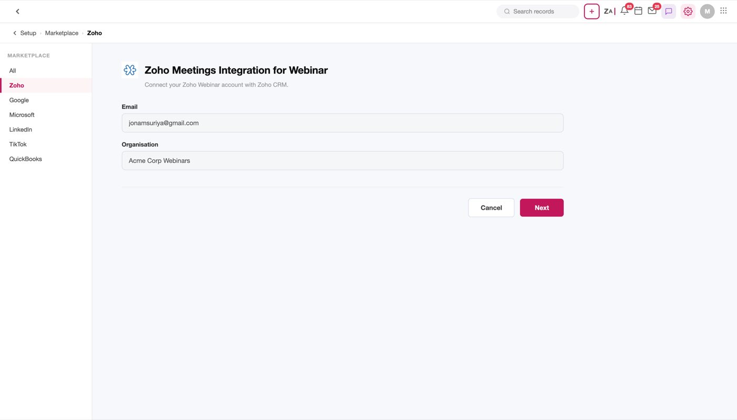
Figure 3 — Step 1 — Email and Organisation
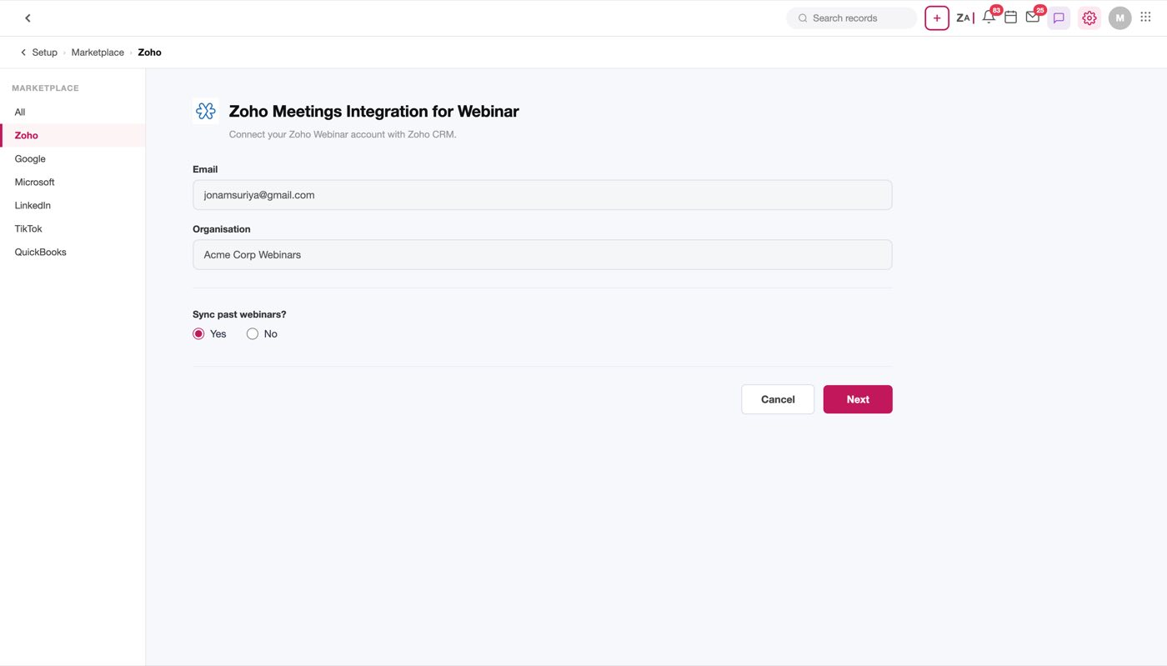
Figure 4 — Step 2 — Sync past webinars? Yes/No radios, Yes preselected
Step | What it asks | Control | Default
1 | Email + Organisation | Text / picklist | the signed-in user's
2 | Sync past webinars? | Radio — Yes / No | Yes
3 | Who Can Participate From CRM | Checkbox list | Leads + Contacts, locked
4 | Webinar Deal Attribution | Card select, 6 models | Linear

Step 4's Next button reads Enable Integration rather than Next, because it is the last one — pressing it turns the integration on and lands on the enabled page, which shows the same settings again plus a dirty-state Save bar.
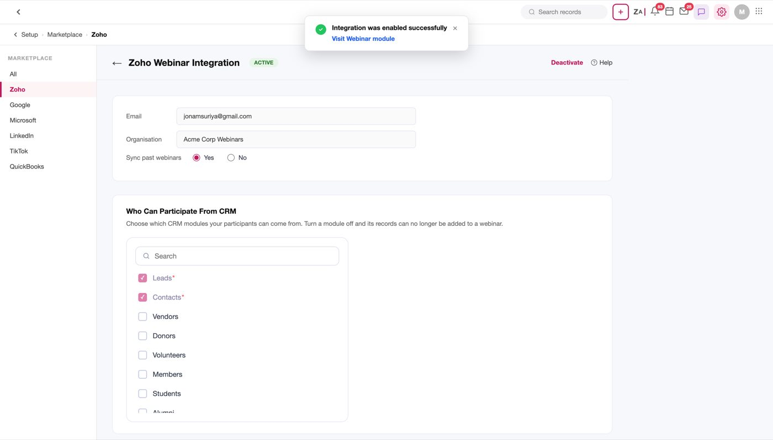
Figure 5 — The enabled page. Same settings, now with a Save bar
Figure 6 — The account gate. Three blocking cases stop before the introduction page; only a valid account continues
Figure 7 — The four-step wizard. Every step's Cancel returns to the introduction page; step 4's Next is Enable Integration

1.1 Who can participate from CRM
Step 3 of the wizard. This is the list of CRM modules whose records may be invited to a webinar. It is the single most load-bearing setting in the integration: turn a module off here and it disappears from the module dropdown in Send Invite (§4.1). Nothing else surfaces the consequence, so a developer must treat this list as the source of truth for that dropdown.
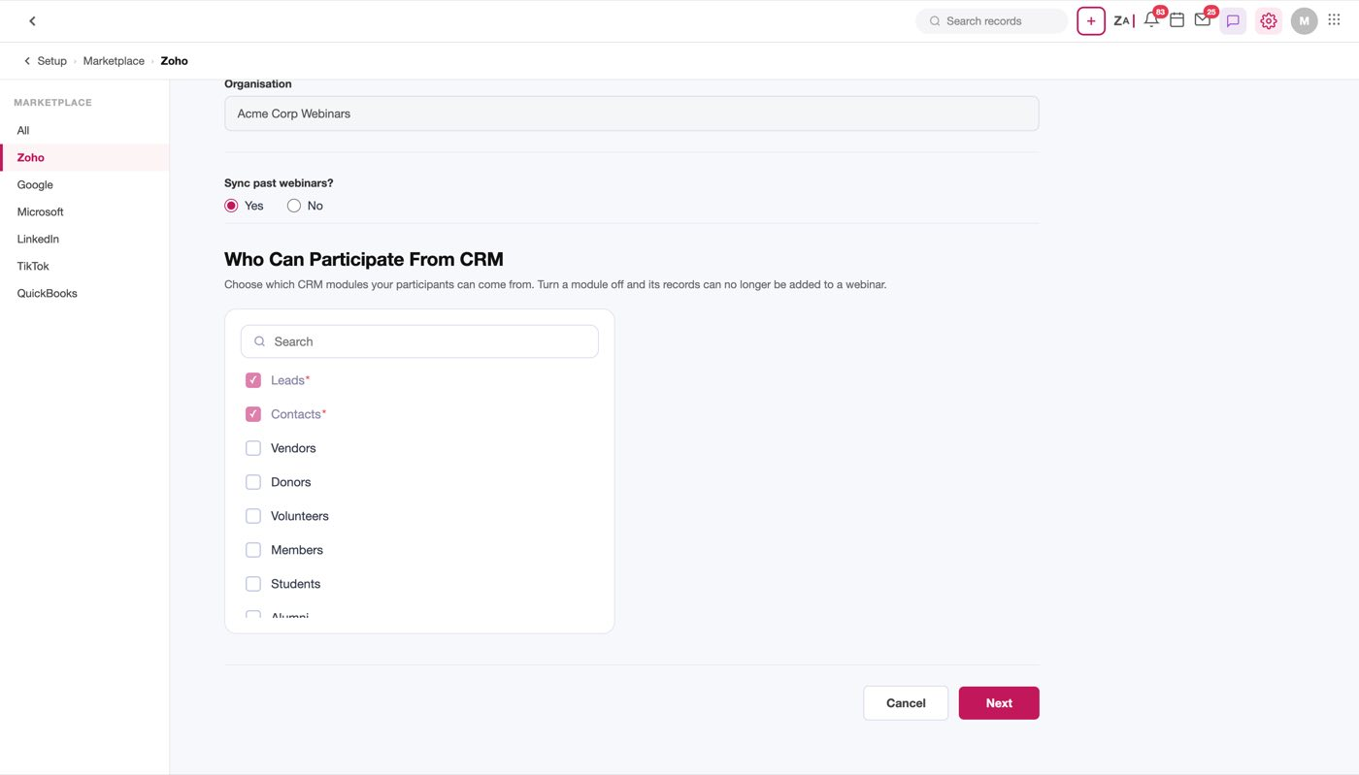
Figure 8 — Step 3. A search box over a flat checkbox list. Leads and Contacts are ticked, greyed and cannot be turned off
The control is CRM's standard module picker: one card, a Search field, then a flat scrollable checkbox list.
Every module, verbatim, in list order (IM_MODULES):
# | Module | State
1 | Leads | Locked on — ticked, red asterisk, cannot be unticked
2 | Contacts | Locked on — ticked, red asterisk, cannot be unticked
3 | Vendors | off by default
4 | Donors | off by default
5 | Volunteers | off by default
6 | Members | off by default
7 | Students | off by default
8 | Alumni | off by default
9 | Partners | off by default
10 | Speakers | off by default
11 | Referrals | off by default
12 | Patients | off by default
13 | Subscribers | off by default

The rule: IM_LOCKED = ["Leads", "Contacts"]. The toggle handler returns early for anything in that list, so the two cannot be switched off by any route. Everything else starts unchecked, which means a freshly enabled integration can invite Leads and Contacts and nothing else.
Note
Every module in this list is a person — someone who can hold an email address and sit in a seat. Accounts, Potentials, Cases, Campaigns and Meetings were deliberately removed: a company, a deal, a ticket, a campaign and an event cannot attend a webinar. Any module added here in future must satisfy the same test.

Note
Mechanically this setting gates who can be invited, not who can attend — anyone holding the public registration link can still register. The heading says "participate" as a statement of intent, not a literal description of the control.

Open question
A module can be turned off after invites have already been sent to its records. What happens to those existing invited records is not modelled.

1.2 Webinar deal attribution
Step 4 of the wizard. A contact usually attends more than one webinar before a deal closes. This setting decides how that deal's revenue is divided across them, and it is what makes the ROI figures in §5.2 mean anything.
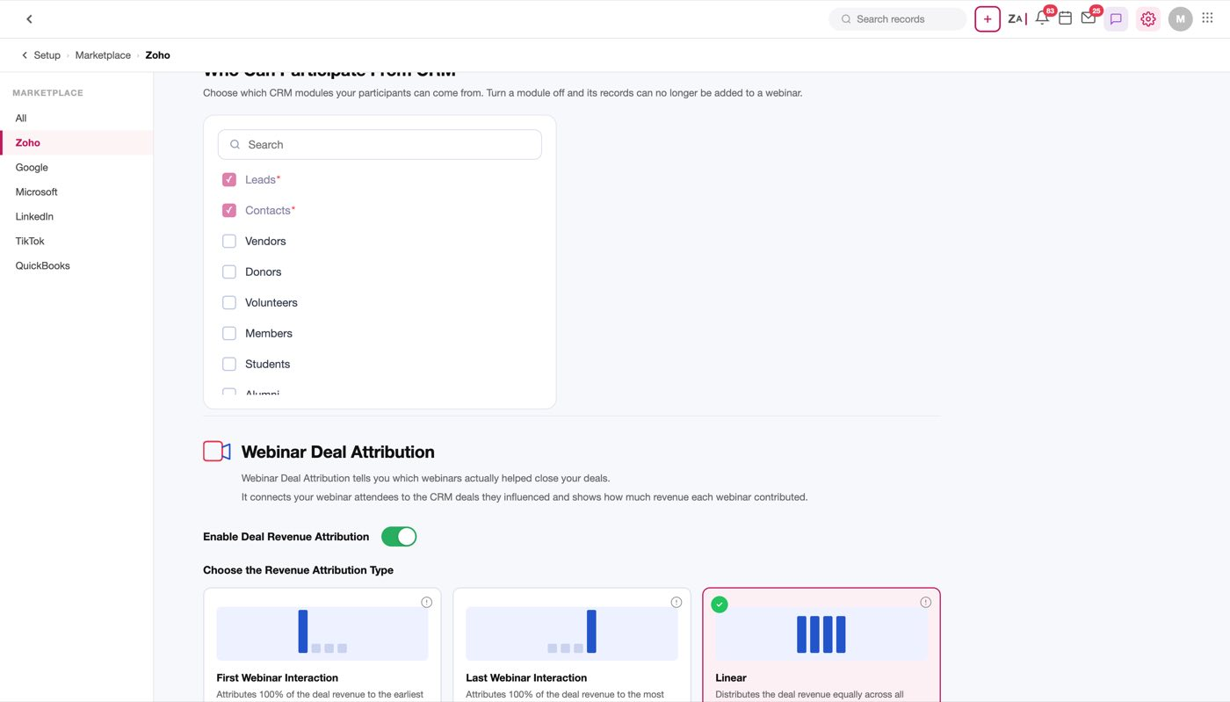
Figure 9 — Step 4 — Webinar Deal Attribution
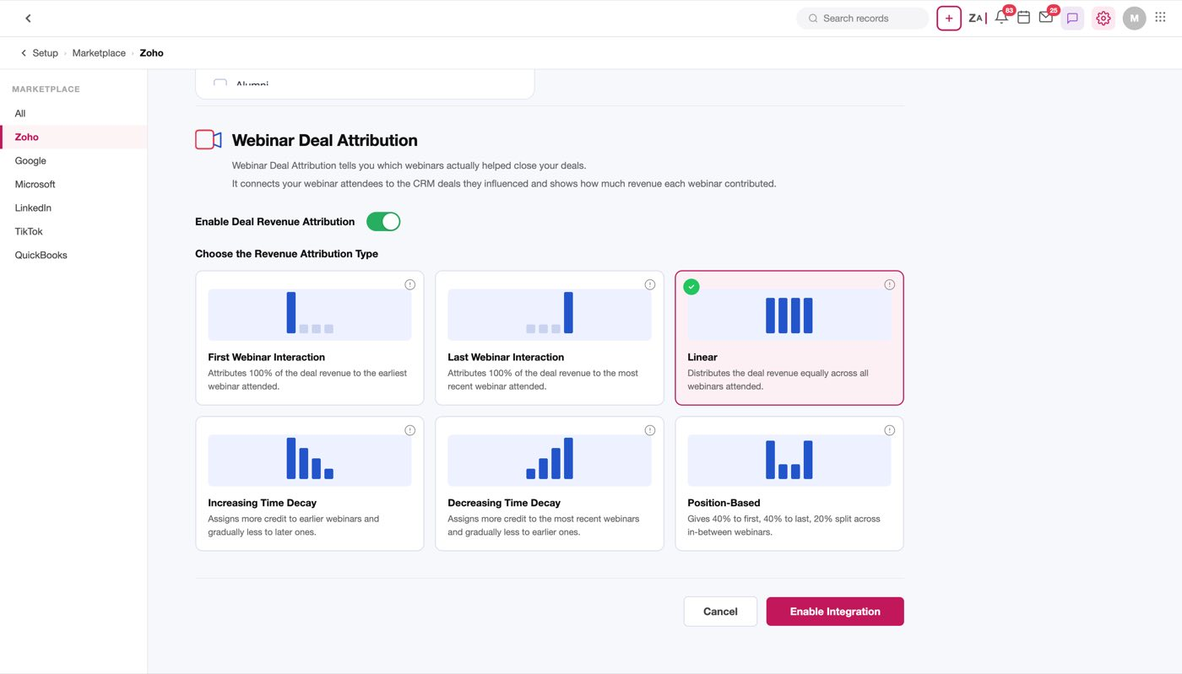
Figure 10 — The six models as selectable cards. Linear carries the selected state
Six models, presented as cards. Verbatim descriptions, in the order shown:
Model | What it does
First Webinar Interaction | Attributes 100% of the deal revenue to the earliest webinar attended.
Last Webinar Interaction | Attributes 100% of the deal revenue to the most recent webinar attended.
Linear (default) | Distributes the deal revenue equally across all webinars attended.
Increasing Time Decay | Assigns more credit to earlier webinars and gradually less to later ones.
Decreasing Time Decay | Assigns more credit to the most recent webinars and gradually less to earlier ones.
Position-Based | Gives 40% to first, 40% to last, 20% split across in-between webinars.

Linear is preselected. In the mock the selected card is marked by an inline pink border (#C2185B) and pink fill (#fdf0f4) rather than a class, so anything reading selection state out of the DOM must look at the style, not a class name.
Note
Only Position-Based states its split numerically (40/40/20). The two Time Decay models describe a direction but no decay function and no half-life, so the actual weighting is unspecified. That has to be defined before this can be built.

Open question
The two Time Decay descriptions read inverted against the usual meaning of the term — "Increasing Time Decay" gives more credit to earlier webinars. Confirm whether the names or the descriptions are what's wrong before implementing either.

Open question
What counts as an interaction for attribution — attending, or merely registering? §5.2 divides by attendees, which implies attendance, but the model descriptions all say "attended" while the deal could equally have been influenced by a no-show who watched the recording.

---

2. Webinar list page
Zoho Webinar is a CRM module, so its landing page is a CRM list view — the same shell as Leads or Contacts, with the module's own columns.
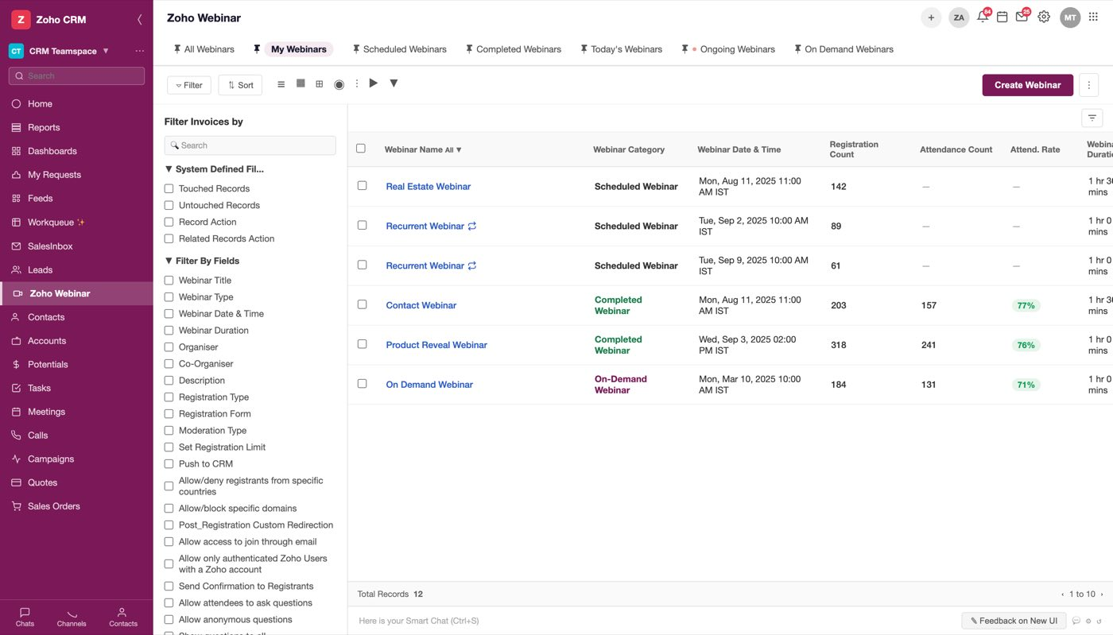
Figure 11 — The Zoho Webinar module list view
Columns, in order:
# | Column | Notes
1 | (checkbox) | row select
2 | Webinar Name | carries the "All ▼" view selector
3 | Webinar Category | Scheduled Webinar / Completed Webinar / On-Demand Webinar
4 | Webinar Date & Time | e.g. Mon, Aug 11, 2025 11:00 AM IST
5 | Registration Count | integer
6 | Attendance Count | `—` until the webinar has happened
7 | Attend. Rate | `—` until the webinar has happened, e.g. 77%
8 | Webinar Duration | e.g. 1 hr 30 mins
9 | Organiser | user
10 | Webinar Type | Live Webinar / On-Demand Webinar

Actions on the page: ▿ Filter, ⇅ Sort, Create Webinar, and a ⋮ overflow.
The category drives the record. Which sections a record shows (§4 vs §5) follows from Webinar Category, not from comparing the date to now — a Scheduled Webinar shows Start Webinar / Send Invite / View Registration Link in its header, a Completed Webinar shows neither and gains Webinar Revenue instead.
Note
Attendance Count and Attend. Rate render as an em dash rather than 0 for a webinar that has not happened. That distinction matters: zero attendance and not yet known are different states and must not both be stored as 0.

Sample use case
A recurring webinar appears as one row per occurrence — the mock lists "Recurrent Webinar" twice, on Sep 2 and Sep 9, each with its own registration count.

---

3. Create webinar
Where it starts: the Create Webinar button on the list page.
The form is five sections in a single scroll — Webinar Details, Registration Setup, Preferences, Reminders, Follow-Ups — and it carries 63 fields in total, of which 42 are visible in the default configuration. The rest are revealed by the branches below.
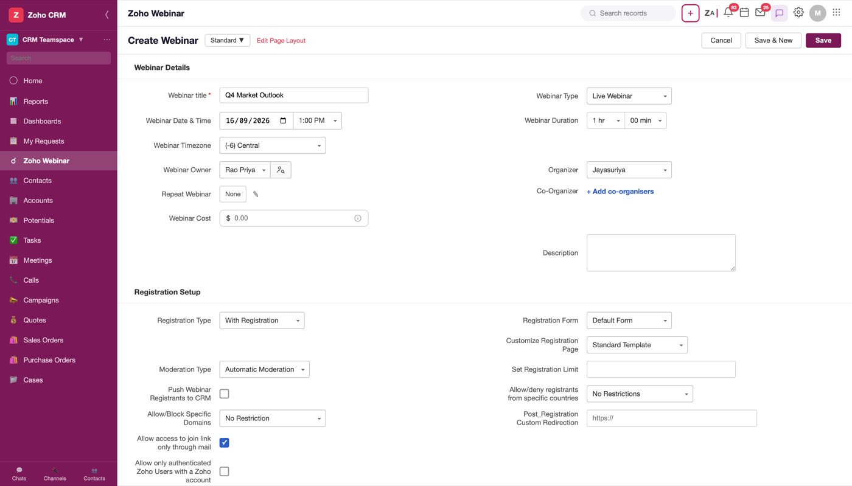
Figure 12 — The Create Webinar form, Webinar Details section
Only one field is required: Webinar title. Saving without it is refused.
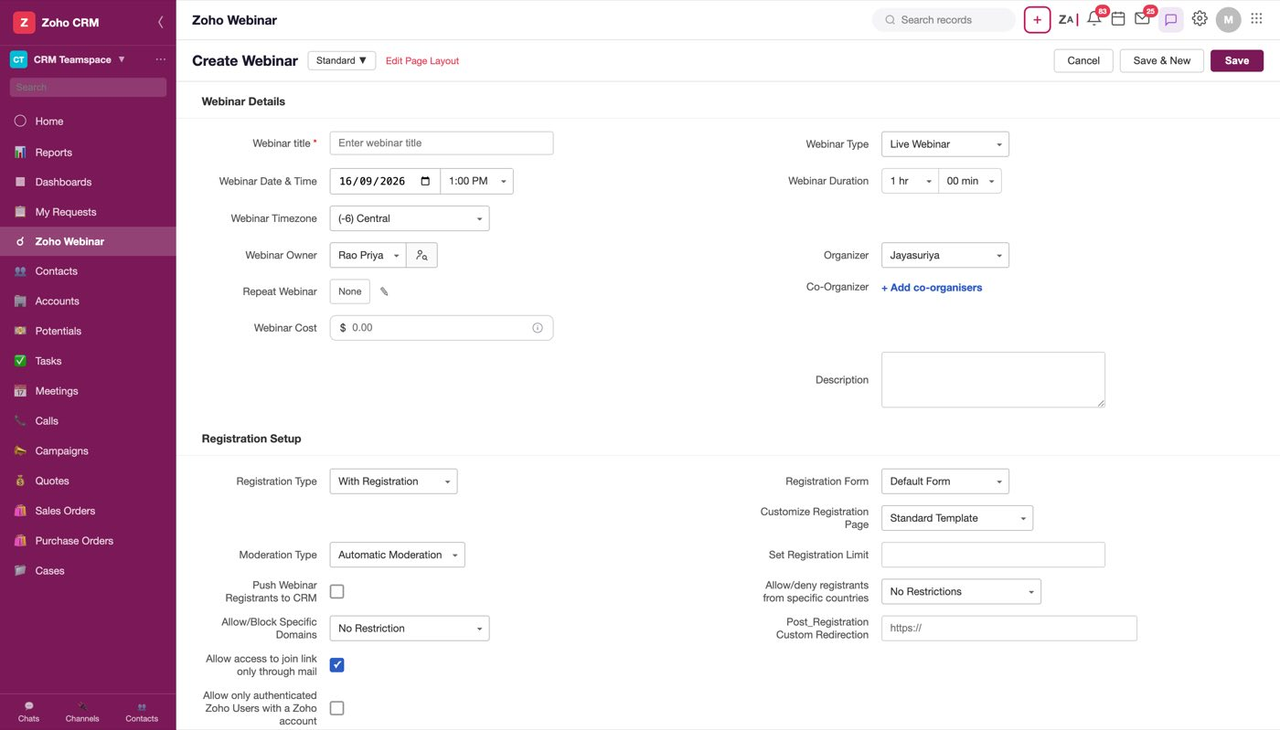
Figure 13 — Save with an empty title. The field is marked and the save does not proceed
Two picklists restructure the form, and they are the two branches worth understanding before anything else:
- Webinar Type — Live Webinar (default) / OnDemand Webinar → §3.1, §3.2
- Registration Type — With Registration (default) / Without Registration
Figure 14 — Create Webinar, with the branches that restructure the form

3.1 Live webinar
The default. Webinar Details in flow order:
Field | Type | Required | Default | Options
Webinar title | Text | Yes | (placeholder: Enter webinar title) | —
Webinar Type | Picklist | No | Live Webinar | Live Webinar, OnDemand Webinar
Webinar Date & Time | Date input + time picklist | No | today + 10:00 AM | 9:00 AM, 10:00 AM, 11:00 AM, 12:00 PM, 1:00 PM, 2:00 PM …
Webinar Duration | Compound picklist (hr + min) | No | 1 hr + 00 min | 1–24 hr; minutes in 00/15/30/45
Webinar Timezone | Picklist | No | (-6) Central | (-5) Eastern, (-6) Central, (-7) Mountain, (-8) Pacific, (+0) UTC, (+5:30) IST
Webinar Owner | Picklist + user lookup | No | Rao Priya | Rao Priya, Jay Acme, Mark Acme, Suriya → §3.3
Organizer | Picklist w/ search | No | Jayasuriya | Jayasuriya, Morrison Troy
Repeat Webinar | Custom control → modal | No | off | → repeat modal
Co-Organizer | Custom control → panel | No | None | → co-organiser panel
Webinar Cost | Text, $ prefix | No | (placeholder: 0.00) | → §3.3
Description | Textarea | No | empty | —

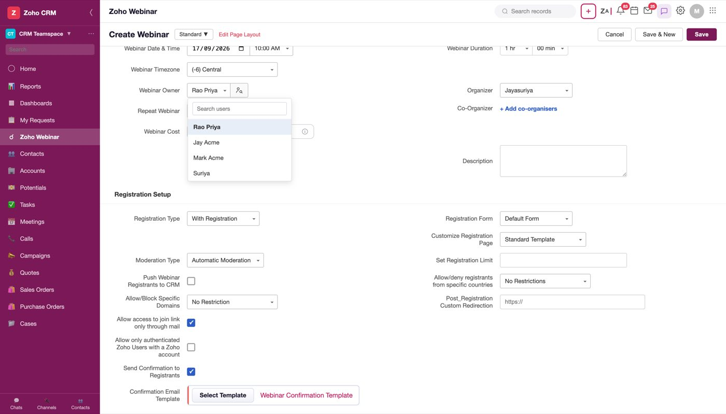
Figure 15 — Webinar Owner open. A search box over the user list — the same shell Organizer uses
Repeat Webinar opens its own modal (Repeat Type, Repeat Ends — On / After n Webinars).
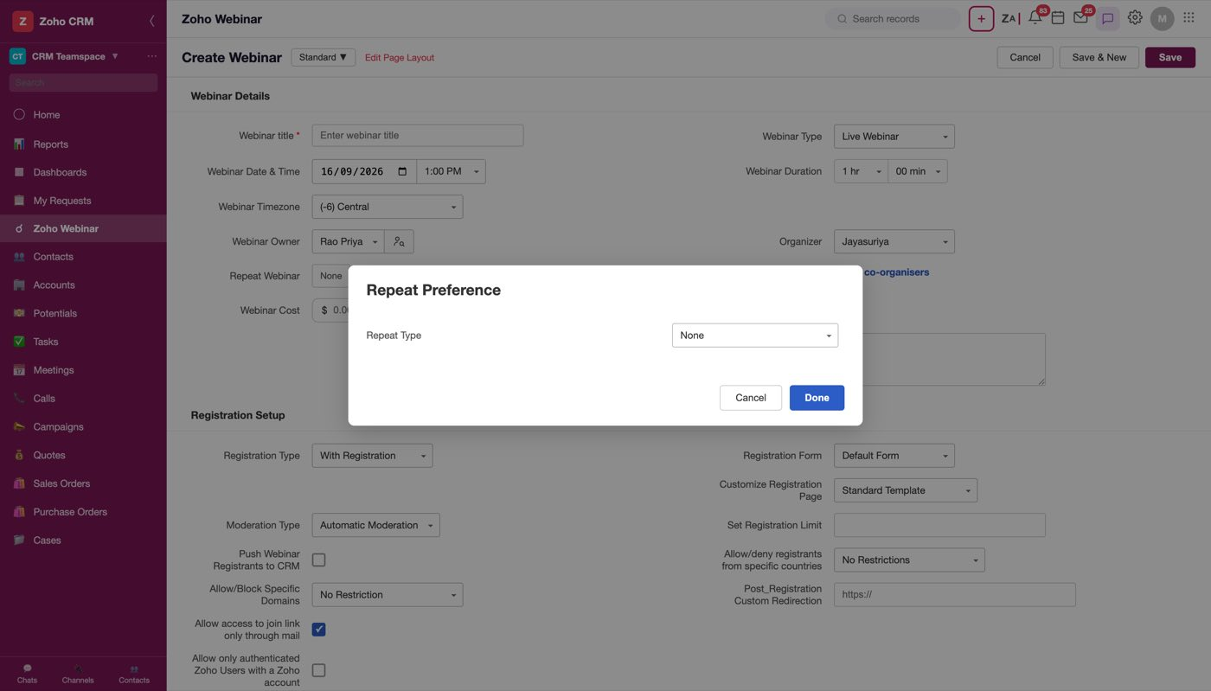
Figure 16 — The Repeat Webinar modal
Registration Setup, with Registration Type = With Registration:
Field | Type | Required | Default | Options
Registration Type | Picklist | No | With Registration | With Registration, Without Registration
Registration Form | Picklist | No | Default Form | Default Form, Real Estate Form, Stock Trading Form, + Create New Form → §3.3
Customize Registration Page | Picklist | No | Standard Template | Standard Template, Custom Created
Moderation Type | Picklist | No | Automatic Moderation | Automatic Moderation, Manual Moderation
Set Registration Limit | Text | No | empty | —
Push Webinar Registrants to CRM | Checkbox | No | unchecked | → §3.3
Allow/deny registrants from specific countries | Picklist | No | No Restrictions | No Restrictions, Allow registrants from Countries, Block registrants from Countries
Allow/Block Specific Domains | Picklist | No | No Restriction | No Restriction, Allow specific email domains, Block specific email domains
Post_Registration Custom Redirection | Text | No | (placeholder: https://) | —
Allow access to join link only through mail | Checkbox | No | checked | —
Allow only authenticated Zoho Users with a Zoho account | Checkbox | No | unchecked | —
Send Confirmation to Registrants | Checkbox | No | checked | —
Confirmation Email Template | Template picker | No | Webinar Confirmation Template | —

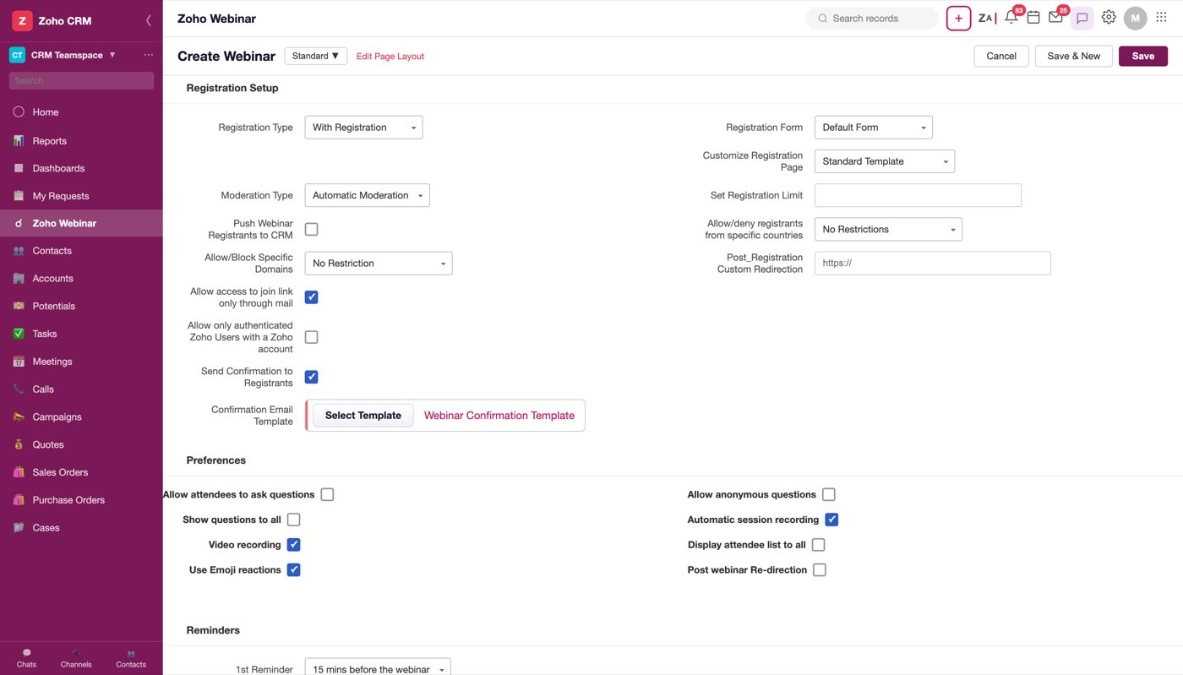
Figure 17 — Registration Setup
Customize Registration Page reveals an eye icon on hover over either option, which previews the public registration page as a registrant will see it — built from the title, date and time currently on the form rather than fixed sample text.
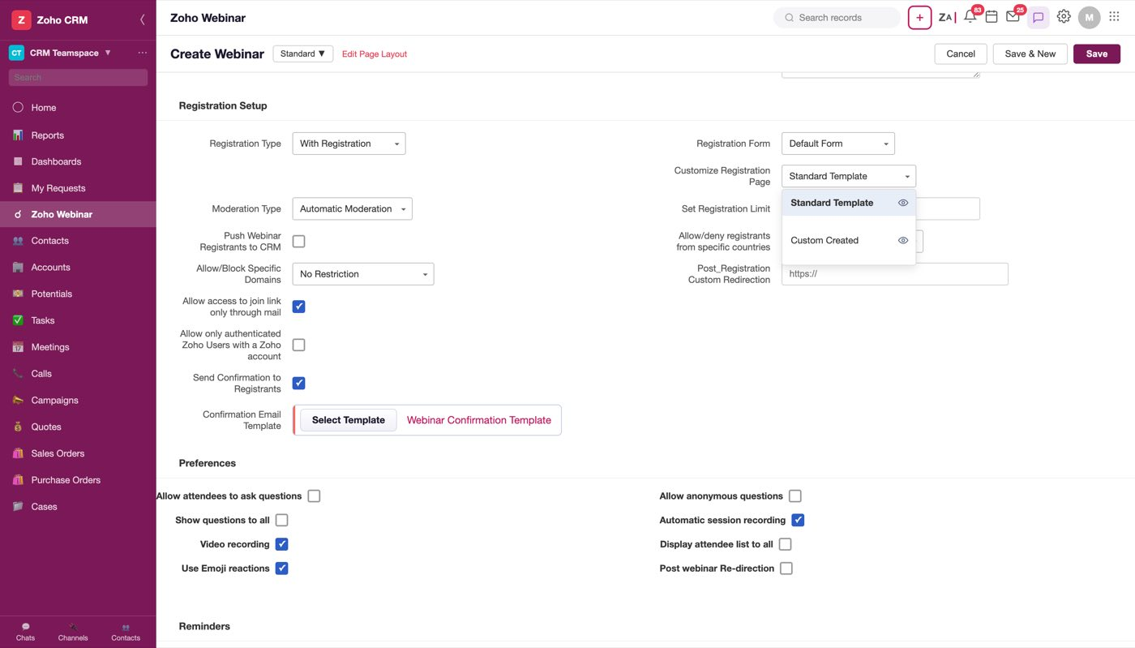
Figure 18 — The picklist, with the hover eye that opens the preview
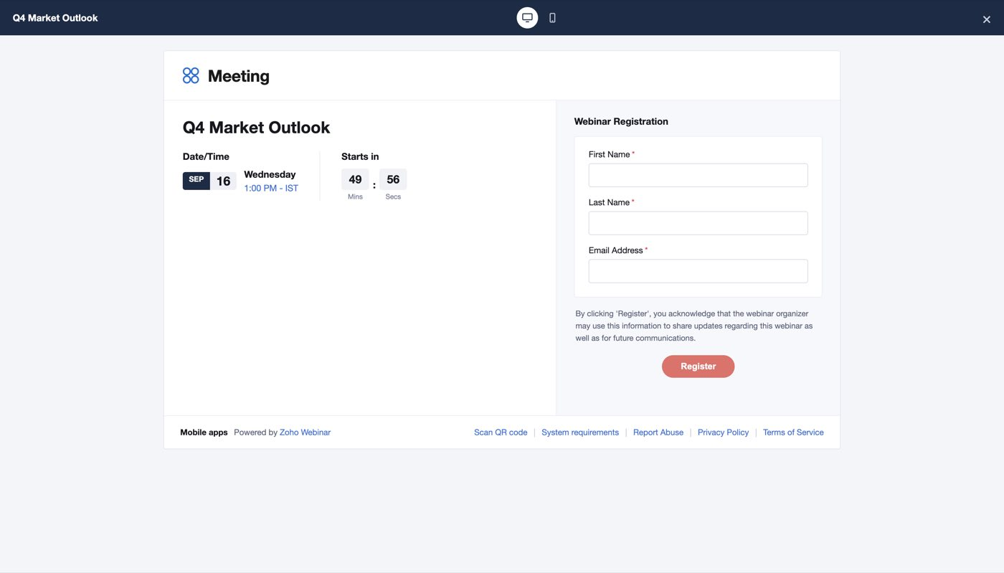
Figure 19 — Standard Template — First Name, Last Name, Email
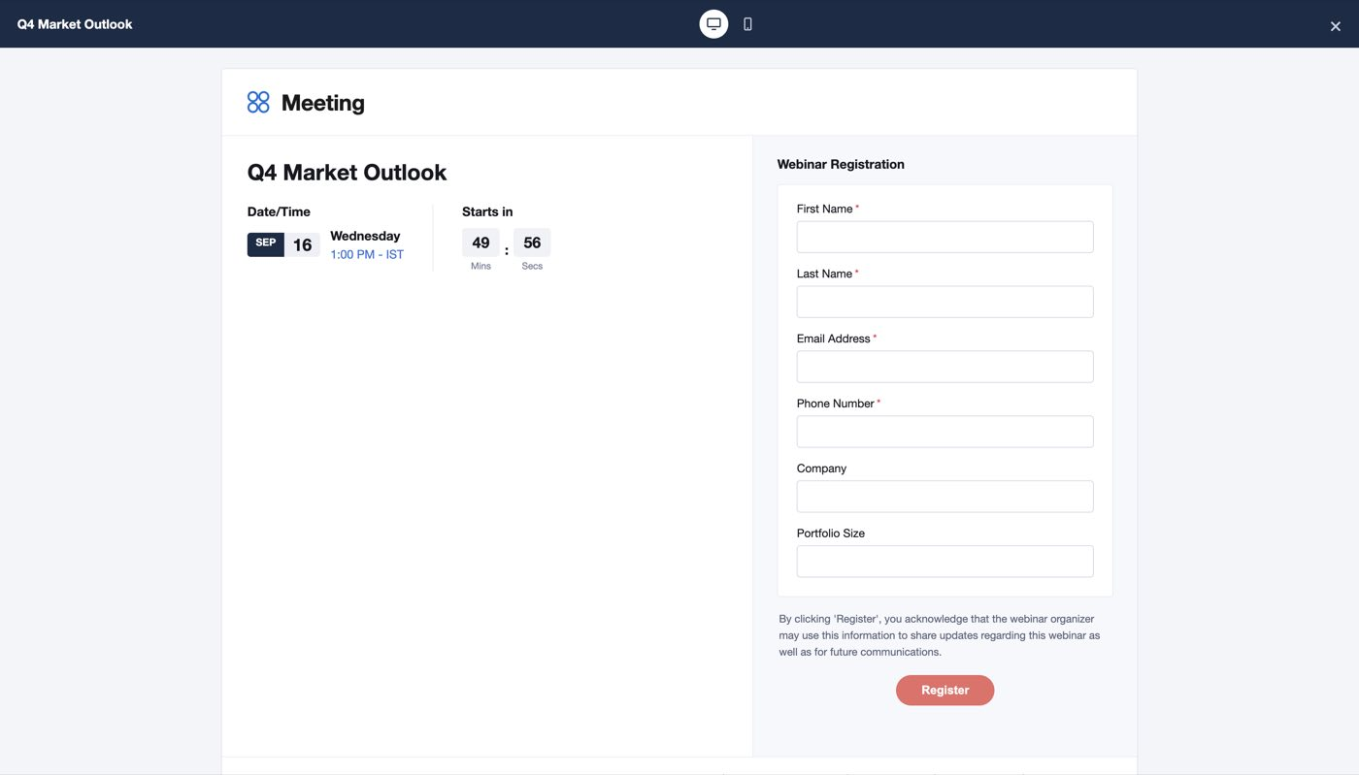
Figure 20 — Custom Created — adds Phone Number, Company and Portfolio Size
The preview has a desktop/mobile toggle; mobile narrows the card to 420px and stacks the two columns.
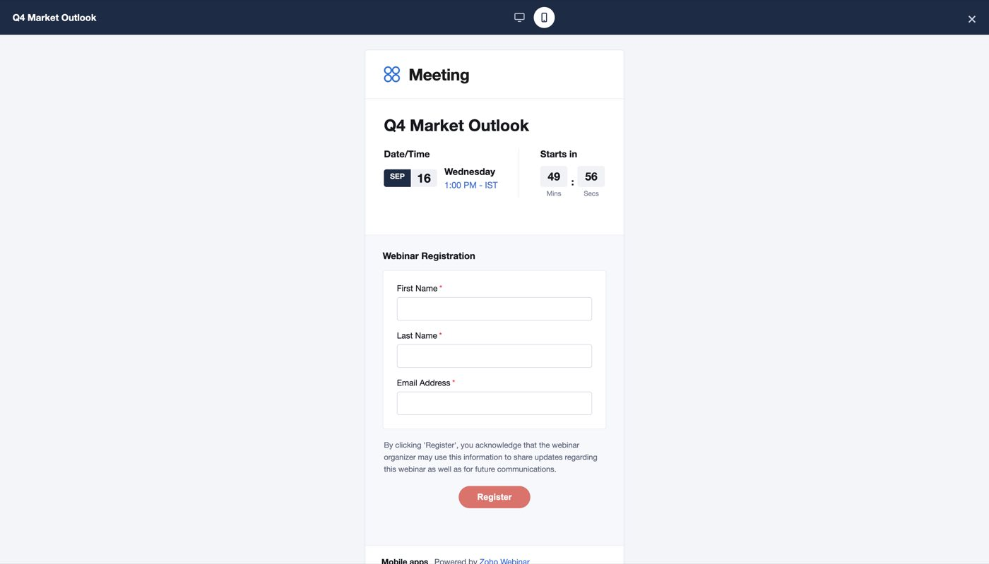
Figure 21 — The same page, mobile layout
Choosing `Without Registration` hides the entire registration apparatus — all thirteen fields above except Registration Type — and reveals three others instead:
Revealed | Type | Why
Who can Join | Picklist | with no registration there is no registrant list, so access is decided here
Send thank you email to attendees | Checkbox | replaces the confirmation/reminder chain
Thank You Email Template | Template picker | its template

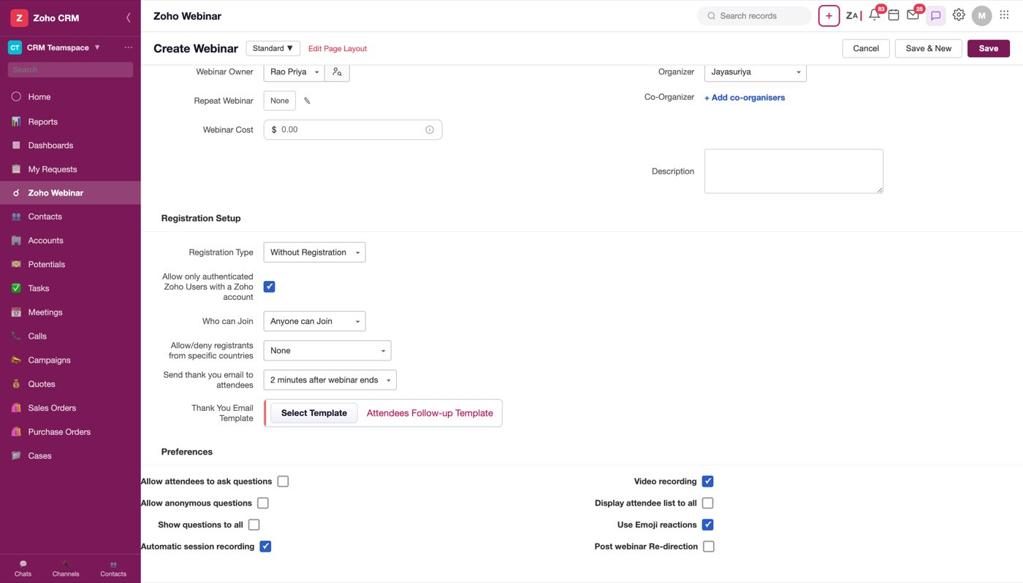
Figure 22 — Without Registration. Registration Form, limits, moderation and the whole reminder chain are gone
Note
Without Registration removes the reminder and follow-up chain entirely — 1st/ 2nd/3rd Reminder, both Follow-ups and both Include Recording settings all disappear, because those emails address a registrant and there are none. Only "Send thank you email to attendees" survives.

Preferences, Reminders and Follow-Ups share the remainder of the scroll:
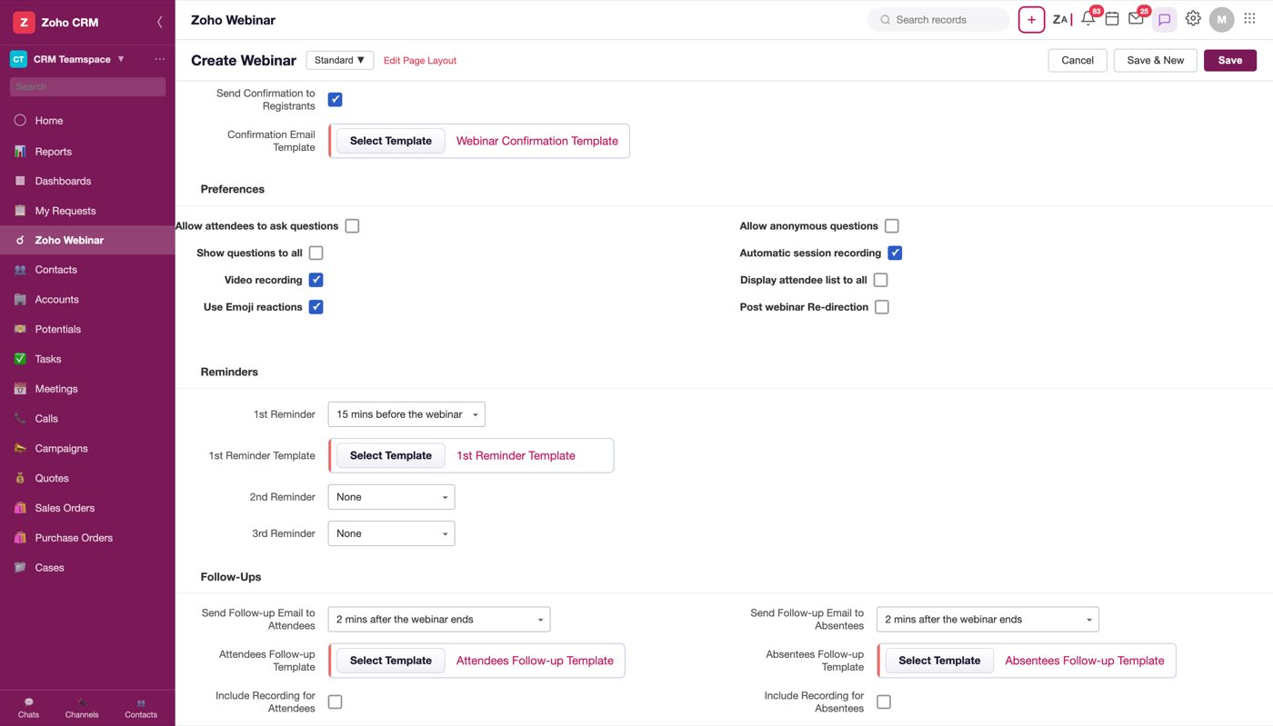
Figure 23 — Preferences, Reminders and Follow-Ups — the form's scroller maxes out around 770px, so all three land in one screenful
Field | Type | Default | Options
Allow attendees to ask questions | Checkbox | — | —
Allow anonymous questions | Checkbox | — | —
Show questions to all | Checkbox | — | —
Auto Reply for questions | Checkbox (revealed) | — | —
Automatic session recording | Checkbox | — | —
Video recording | Checkbox | — | —
Display attendee list to all | Checkbox | — | —
Use Emoji reactions | Checkbox | — | —
Post webinar Re-direction | Checkbox | — | —
1st Reminder | Picklist | 15 mins before the webinar | 2/5/10/15/30 mins, 1/2/6/12 hours, 1 day, 1 week before the webinar
2nd Reminder | Picklist | None | None, then the same eleven intervals
3rd Reminder | Picklist | None, then the same eleven intervals
Send Follow-up Email to Attendees | Picklist | 2 mins after the webinar ends | None, 2/5/10/15 mins, 1/2/6 hours, 1 day after the webinar ends
Send Follow-up Email to Absentees | Picklist | 2 mins after the webinar ends | same as above
Include Recording for Attendees | Checkbox | unchecked | —
Include Recording for Absentees | Checkbox | unchecked | —

Note
The 2nd and 3rd reminders carry None on top of the same eleven intervals the 1st offers, and both default to None. That is how a webinar sends fewer than three reminders — there is no separate "number of reminders" setting. The 1st reminder has no None option, so at least one reminder always goes out on a registration webinar.

Each reminder and follow-up has its own template slot, chosen through Select Template:
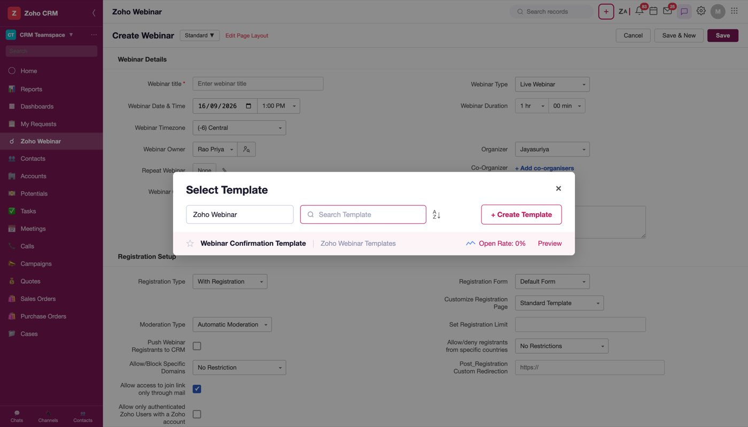
Figure 24 — A template slot's Select Template dialog

3.2 On-demand webinar
Setting Webinar Type = OnDemand Webinar changes what the session is: instead of a live session at a time, it plays a pre-recorded video.
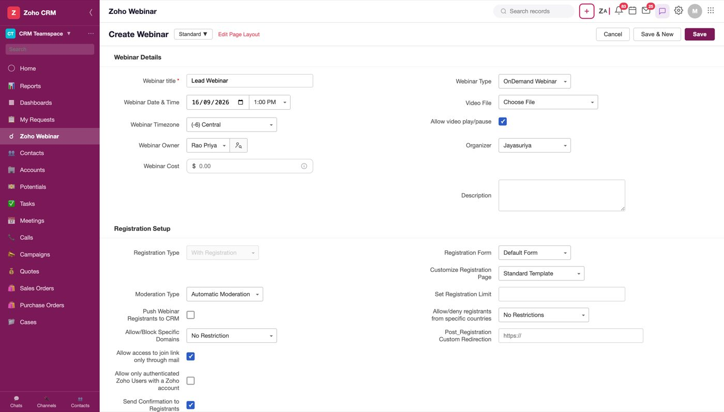
Figure 25 — The on-demand form. Video File replaces Webinar Duration; Allow video play/pause sits directly beneath it
What changes, exactly:
Direction | Field | Note
Gained | Video File | replaces Webinar Duration — the video's own length is the duration
Gained | Allow video play/pause | sits in the Webinar Timezone row's empty right cell, directly under Video File
Lost | Webinar Duration | —
Lost | Repeat Webinar | a recording does not recur
Lost | Co-Organizer | —
Lost | Allow anonymous questions, Show questions to all | there is no live Q&A to moderate
Lost | Automatic session recording, Video recording | it is a recording
Lost | Display attendee list to all, Use Emoji reactions | no shared live audience
Lost | 1st/2nd/3rd Reminder + their templates | —
Lost | Both Follow-up emails + their templates | —
Lost | Include Recording for Attendees / Absentees | —

On-demand keeps 25 visible fields against live-with-registration's 42.
Note
The placement of Allow video play/pause is deliberate: it was moved out of a row of its own so the right column reads Video File → Allow video play/pause → Organizer, putting the setting next to the file it governs rather than two rows away.

Open question
On-demand loses the entire reminder and follow-up chain even though it still has a Webinar Date & Time and still takes registrations. A registrant for an on-demand session therefore gets a confirmation and nothing else — no reminder that it is available, no follow-up. Confirm this is intended rather than a consequence of reusing the live form's visibility rules.

3.3 New fields
Four fields this integration introduces that a plain Zoho Webinar form does not have, or does not have in this form. They are the fields that make the CRM half work, so they are worth reading together.

1. Webinar Owner
Field | Type | Required | Default | Options
Webinar Owner | Picklist with search + user-lookup button | No | Rao Priya | Rao Priya, Jay Acme, Mark Acme, Suriya

Figure 26 — Webinar Owner open — search box, then the user list, with a lookup icon beside the field
Owner is a CRM concept, not a webinar one. Every CRM record has an owner, and it drives record-level sharing, assignment rules and "My Webinars" filters. It is distinct from Organizer, which is the webinar's host — the person who actually runs the session.
Note
Owner and Organizer are separate fields with separate option lists — Owner offers Rao Priya / Jay Acme / Mark Acme / Suriya, Organizer offers Jayasuriya / Morrison Troy. They are not the same directory and must not be collapsed into one field. Both use the same picklist-with-search shell.

2. Webinar Cost
Field | Type | Required | Default | Options
Webinar Cost | Text, $ prefix, info tooltip | No | (placeholder: 0.00) | —

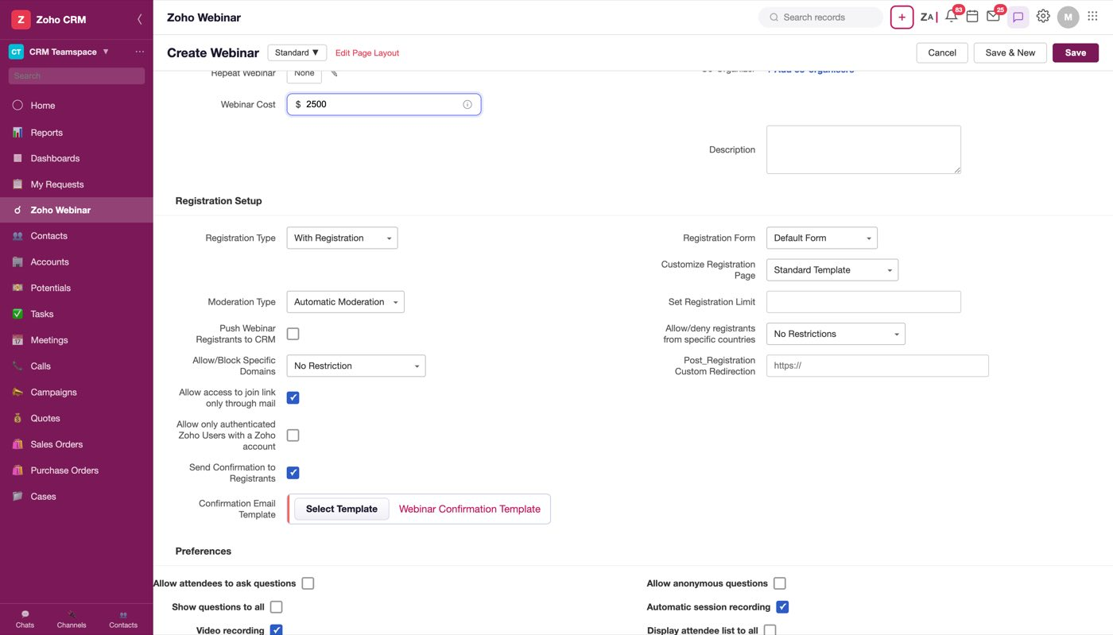
Figure 27 — Webinar Cost — a $ prefix inside the field and an info icon at its right
The tooltip reads: "This is the amount attendees will be charged to register for this webinar."
This field is the denominator of every ROI figure in §5.2. A cost of 2500 entered here is what produces Cost $2,500, ROI +572%, Cost/Attendee $167 and Revenue/Attendee $1,120 on the completed record.
Note
There is a contradiction to resolve. The tooltip says this is what attendees are charged — revenue. §5.2 uses it as what the webinar cost to run — expenditure, the ROI denominator, shown in a tile labelled "Cost" beside a separate "Revenue (Won)" tile fed by closed deals. Both cannot be true. The ROI arithmetic is self-consistent, so the tooltip is the more likely error, but this must be decided before build.

Open question
The field is plain text with no validation and no currency selector, while the $ prefix is hard-coded. Multi-currency orgs need a currency; free-text needs a numeric constraint.

3. Registration Form
Field | Type | Required | Default | Options
Registration Form | Picklist | No | Default Form | Default Form, Real Estate Form, Stock Trading Form, + Create New Form

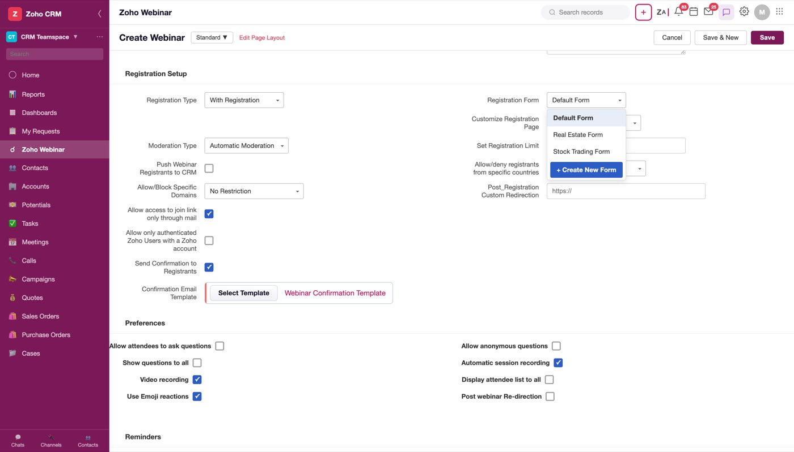
Figure 28 — The Registration Form picklist. Each row reveals a Preview tag on hover
This is the form a registrant fills in on the public registration page — the fields it collects are what you get back about a person who was not already in CRM, which makes it the input side of §3.3.4.
Each option reveals a Preview tag on hover, opening the form builder's preview:
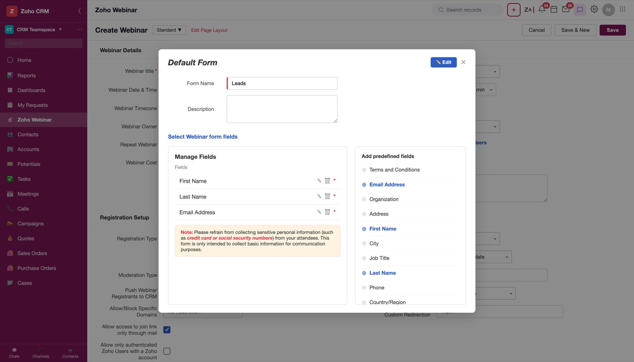
Figure 29 — A registration form preview
+ Create New Form is the last option and opens a form builder rather than selecting anything — a create action living inside a picklist.
Note
Don't confuse Registration Form with Customize Registration Page. The form is which fields are collected; the page is how the public page looks (Standard Template / Custom Created). They are separate picklists sitting one above the other in the same column, and the page preview's field set is driven by the page choice, not this one.

4. Push Webinar Registrants to CRM
Field | Type | Required | Default | Options
Push Webinar Registrants to CRM | Checkbox + Manage Config link | No | unchecked | —

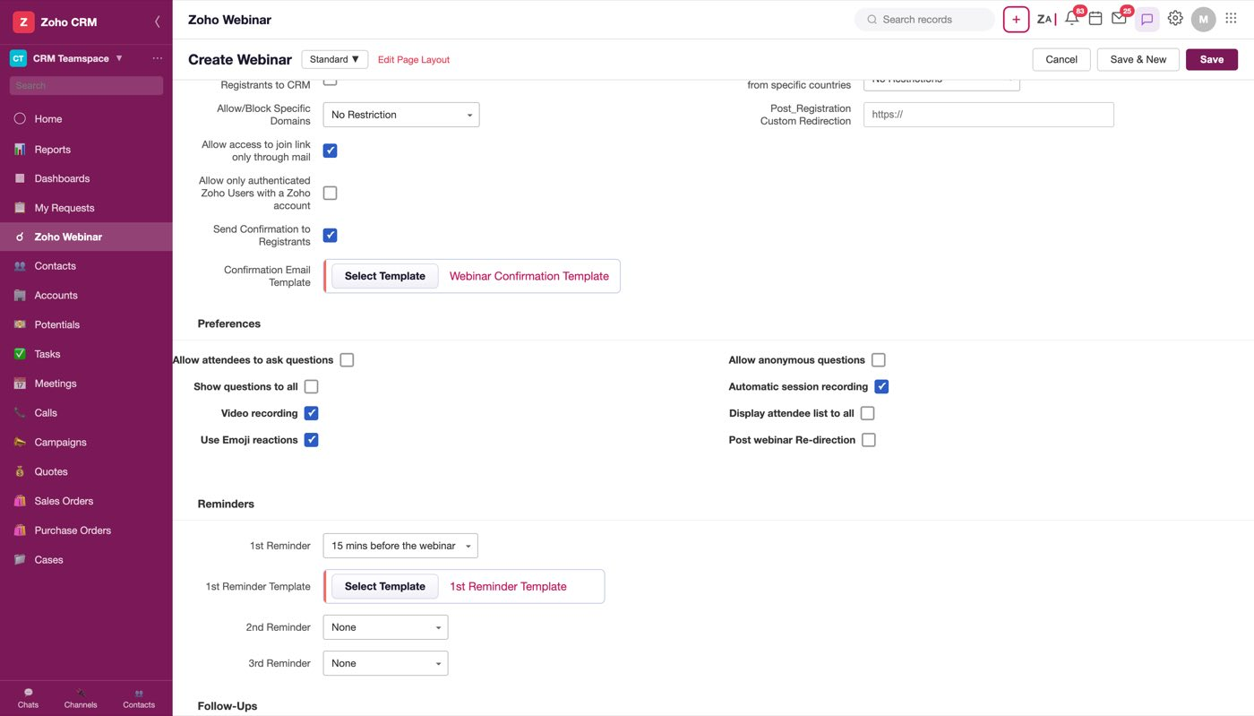
Figure 30 — The checkbox, with Manage Config beside its label
This is the field that closes the loop. Someone who registers from the public link — found the webinar on LinkedIn, was forwarded it, arrived from a tweet — does not exist in CRM. Ticked, they are created as CRM records automatically, and the re-import step disappears.
Manage Config opens the field mapping — which registration form field lands in which CRM field, and which module the new record is created in:
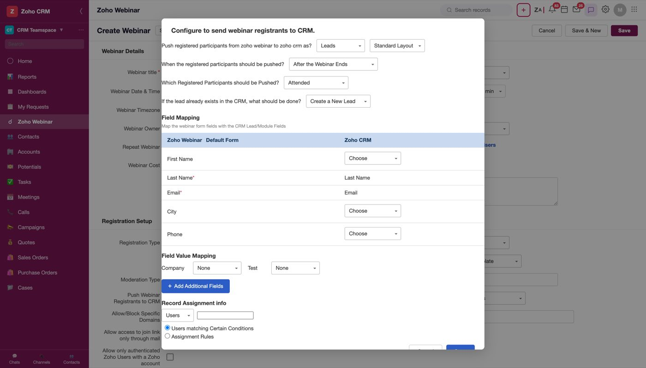
Figure 31 — The Push to CRM configuration
Note
It is off by default, so the loop is open unless someone closes it. Given this is the single feature that most justifies the integration, a default of unchecked is worth challenging.

Open question
Deduplication is not modelled. If a registrant's email already matches a Lead or Contact, it is unspecified whether the existing record is updated, a duplicate is created, or the registrant is skipped.

---

4. Scheduled webinar
A webinar whose Webinar Category is Scheduled Webinar — created, not yet run.
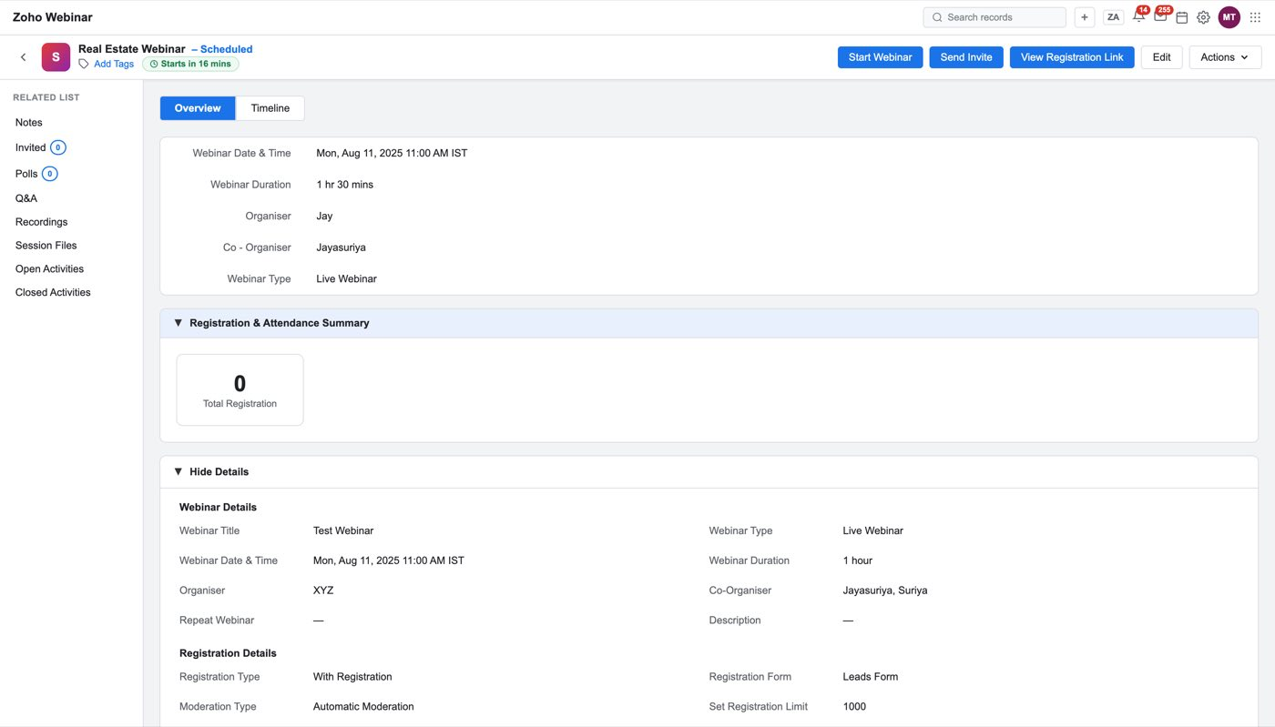
Figure 32 — A scheduled webinar. Start Webinar, Send Invite, View Registration Link, Edit, Actions
Header buttons: Start Webinar · Send Invite · View Registration Link · Edit · Actions Tabs: Overview · Timeline Related list rail: Notes · Invited · Polls · Q&A · Recordings · Session Files · Open Activities · Closed Activities
The Details panel above the summary carries Webinar Date & Time, Webinar Duration, Organiser, Co-Organiser and Webinar Type, with a Hide Details toggle expanding the full Webinar Details and Registration Details blocks.
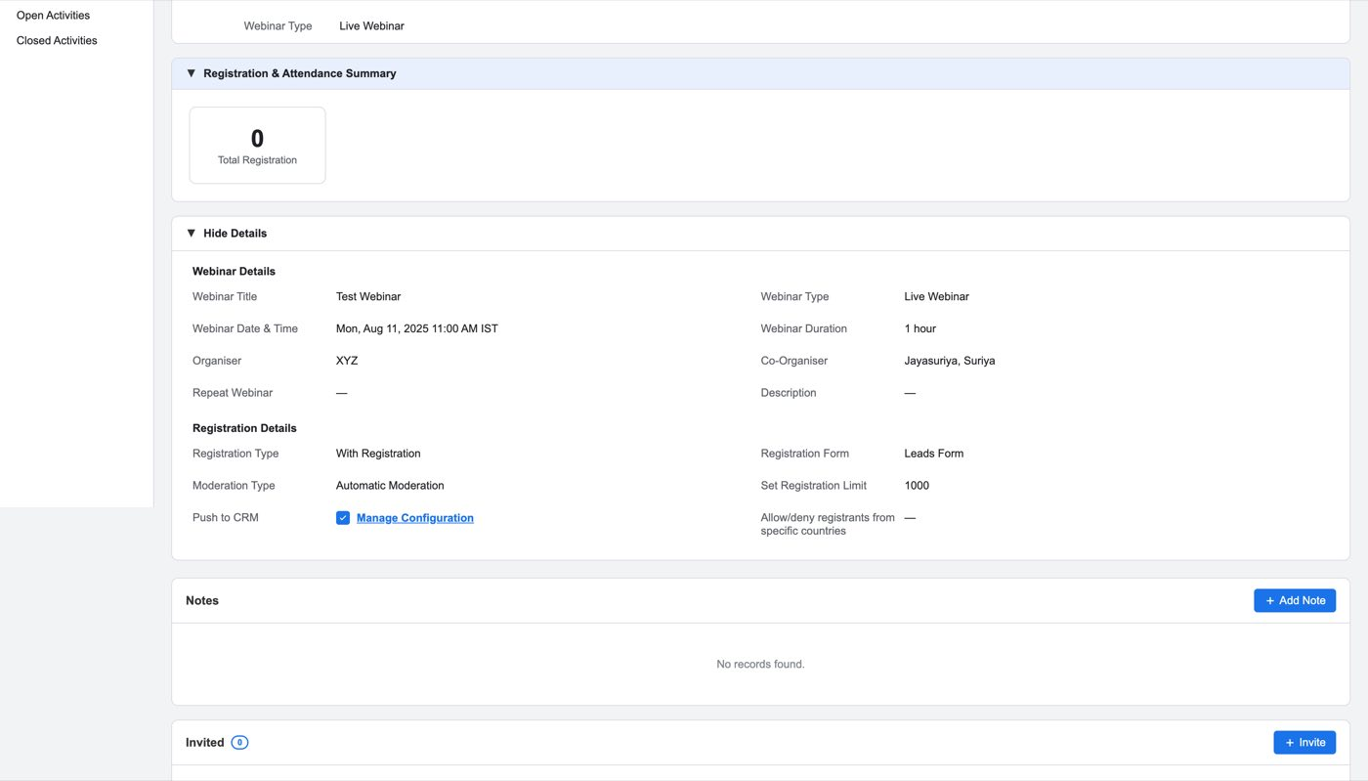
Figure 33 — The expanded Details panel
Note
The detail page scrolls an inner element, not the window. Its scroller maxes out around 2820px on a scheduled webinar and 3812px on a completed one. Anything driving this page programmatically must set scrollTop on that element and cannot rely on scrolling past the maximum.

4.1 Send Invite
The flow that connects the webinar to CRM's records.
Figure 34 — Send Invite end to end. Add commits the selection; Next opens Mass Email
Step 1 — the record picker. A module dropdown, a view filter, then the records.
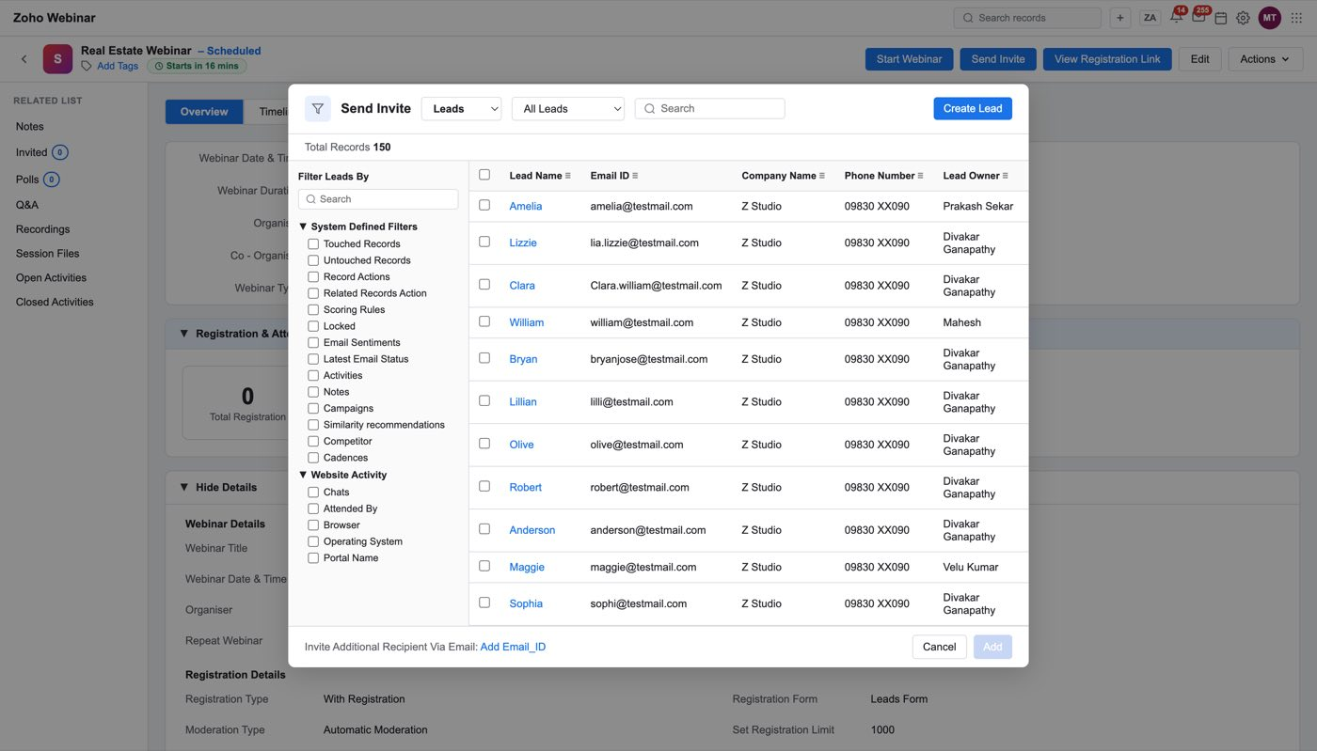
Figure 35 — The record picker. Module dropdown first, then the view, then the records
The module dropdown is populated from §1.1. Only modules enabled in Who Can Participate From CRM appear. Leads and Contacts are always there; anything else appears only if an admin ticked it.
Step 2 — this picker has two internal steps. Tick the record rows, then press Add, which commits the selection and moves to a selected-records list with Remove ALL. Only then does Next do anything.
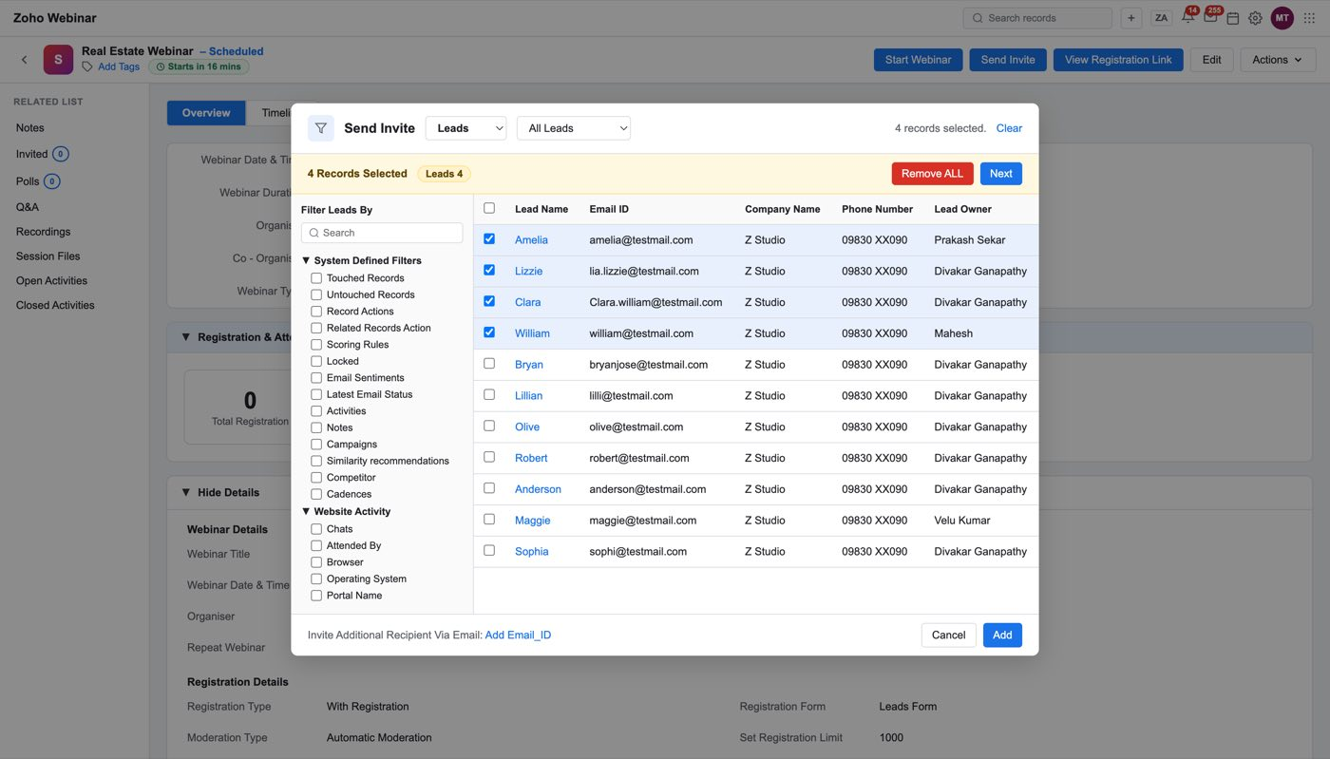
Figure 36 — After Add — the committed selection, with Remove ALL
Note
Pressing Next before Add does nothing at all — no error, no movement. This silently cost time during capture and will cost a developer the same. Either Next should be disabled until a selection is committed, or Add should be removed and Next should commit.

Step 3 — Mass Email. CRM's mass-email compose step.
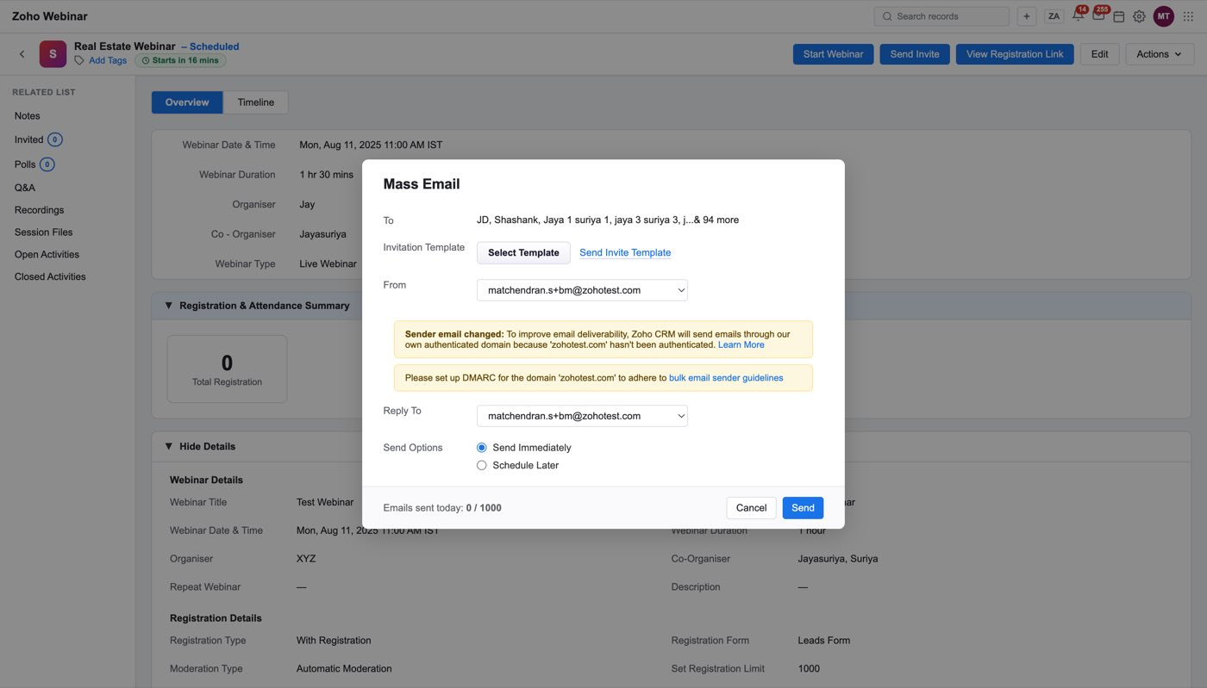
Figure 37 — The Mass Email step
The Invitation Template is chosen through Select Template, which lists only templates whose Email Type is Webinar Invitation:
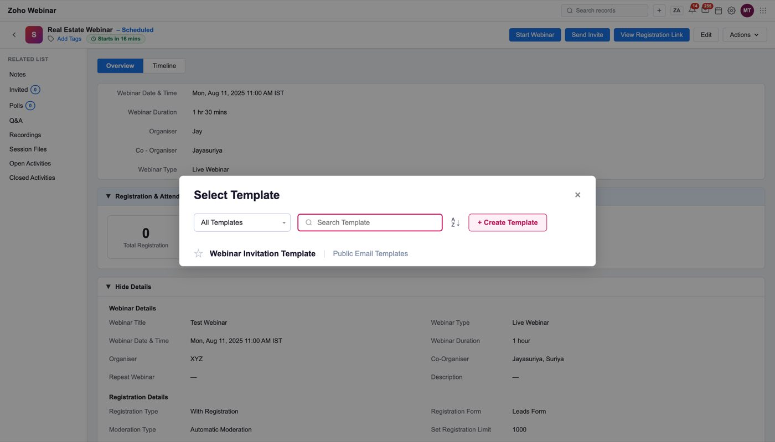
Figure 38 — Select Template. Only Invitation-type templates are offered
Step 4 — what sending does. Two things happen, and both are observable:
- The invited records appear in the Invited related list, each with an invite status
and a webinar status.
- An Email row is created in View Registration Link and Enable Source Tracking is
switched on (§4.2).
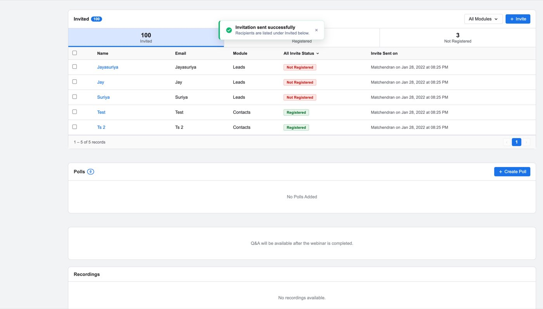
Figure 39 — The Invited section after sending
Open question
Re-inviting is not fully modelled — whether a record already invited can be selected again, and whether that resends or is refused, is unspecified.

4.2 View registration source
View Registration Link in the header opens the public registration link and the list of tracked sources underneath it.
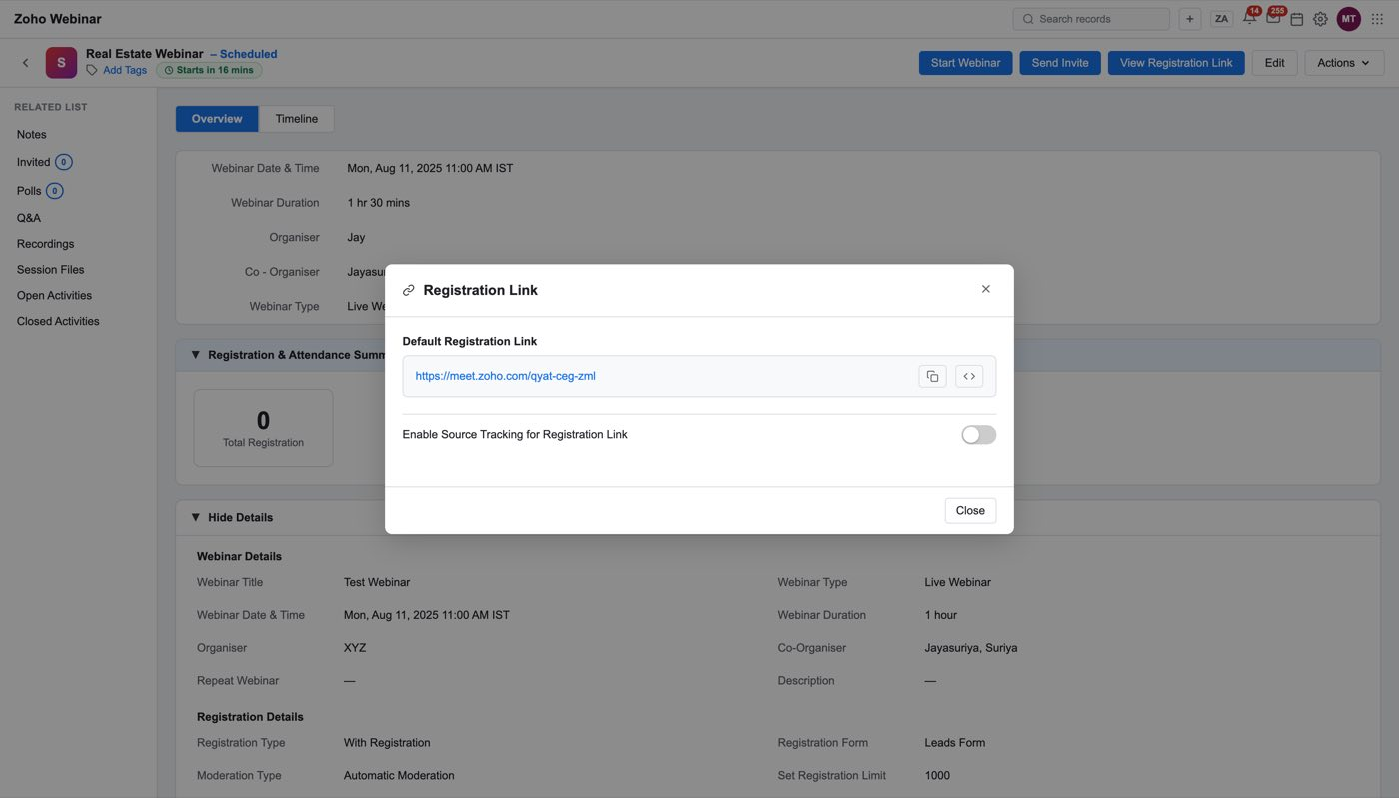
Figure 40 — Before any invite — the default link, source tracking off, no source rows
A webinar nobody has been invited to has no sources at all and the table is empty. This is deliberate: a brand-new webinar should not chart registrations from channels that do not exist yet.
Completing Send Invite creates the first source:
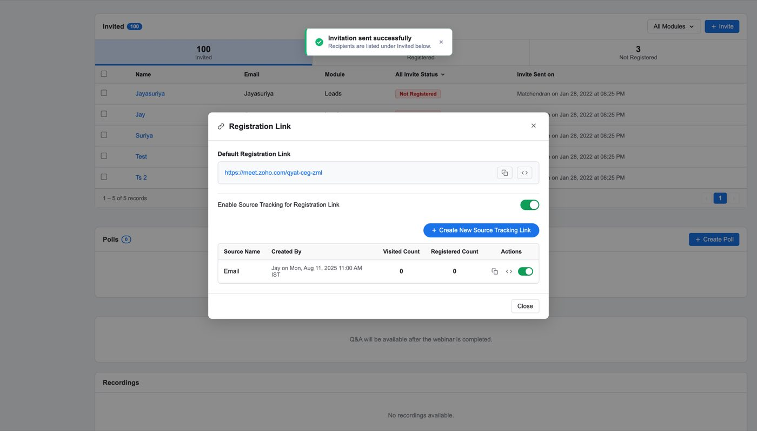
Figure 41 — After sending — Enable Source Tracking is on and an Email row exists
Column | Example
Source | Email
Created by | Jay
Visited | 0
Registered | 0
Status | enabled

Enable Source Tracking switches itself on when the first source is created, because a source with tracking off would record nothing.
Note
A second Send Invite does not add a second Email row — the creation is guarded against duplicates. One channel, one row.

4.3 Registration & Attendance Summary
A collapsible band below the Details panel. On a scheduled webinar it answers "who has signed up so far", and it is deliberately thinner than its completed-webinar counterpart (§5.1) because attendance does not exist yet.
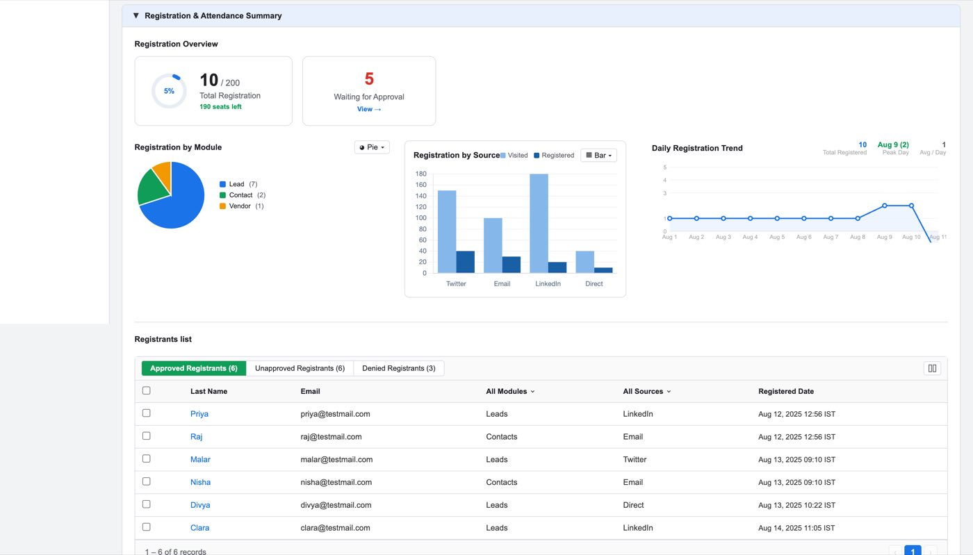
Figure 42 — Registration & Attendance Summary on a scheduled webinar
Block | What it shows
Registration Overview | 10 / 200 Total Registration with a % ring, 190 seats left, and 5 Waiting for Approval with a View → link
Registration by Module | pie — Lead (7), Contact (2), Vendor (1)
Registration by Source | grouped bar, Visited vs Registered per channel
Daily Registration Trend | line — 10 Total Registered, Aug 9 (2) Peak Day, 1 Avg / Day

Registration Overview reads against the limit set by Set Registration Limit (§3.1) — 190 seats left is 200 − 10. With no limit set, there is nothing to count down from.
Waiting for Approval only means something under Moderation Type = Manual Moderation.
Each chart is clickable and opens a drill-down record list (Last Name, Created By, Created Time).
Note
There is no attendance data on a scheduled webinar — no Total Attendees, no Total Absentees, no Attendance by Module or Source. Those four appear only after the session (§5.1). The band keeps its name in both states.

Open question
Every drill-down in the mock reports "0 records" while the chart it opened shows non-zero counts. The drill-down is not wired to real data.

4.4 Poll creation
Polls are written before the session and answered during it.
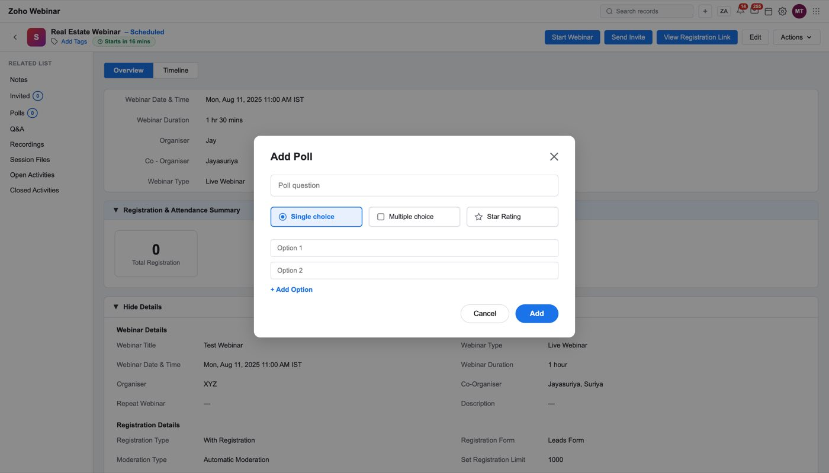
Figure 43 — Creating a poll before the webinar
Create Poll opens the editor. A poll has a question and a set of answer options, and three question types are offered:
Type | Behaviour
Multiple choice | one answer from a list
Short answer | free text
Checkbox | several answers from a list

The Polls related list carries a count badge (Polls 2) once polls exist. Results are empty until the session runs — see §5.4 for the answered state.

4.5 Session Files
The webinar's attachments — slides, handouts, recordings, promotional assets.
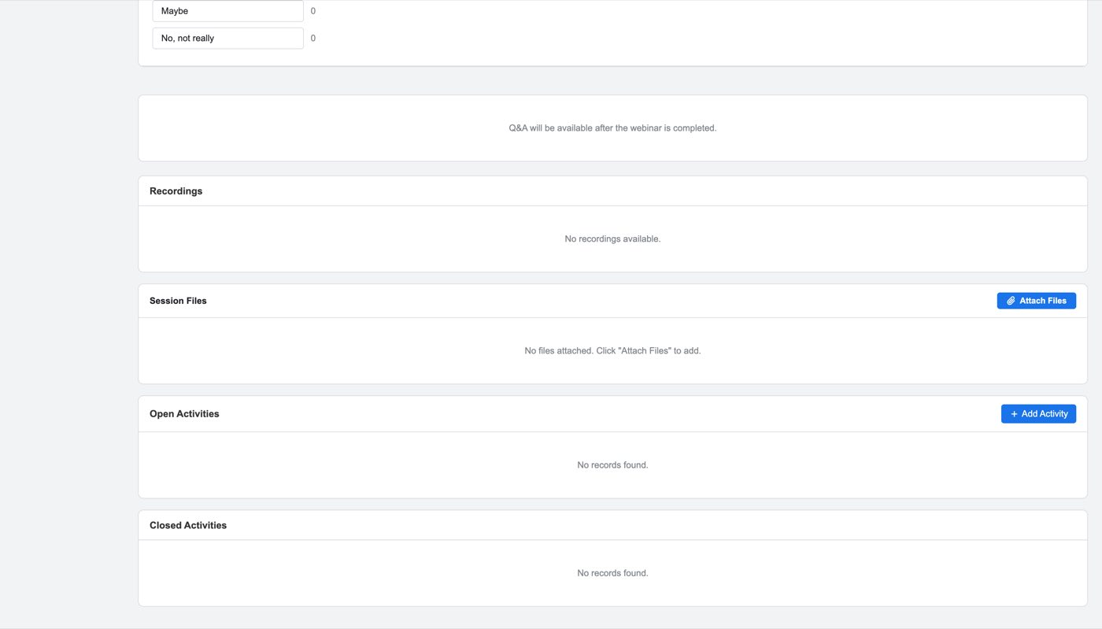
Figure 44 — The Session Files related list
Column | Example
File Name | 📄 Webinar_Slides_Q3.pdf
Size | 3.2 MB
Date Added | Sep 4, 2025

Four sample files, each with a type icon: Webinar_Slides_Q3.pdf (3.2 MB), Product_Demo_Recording.mp4 (128 MB), Attendee_Handout.docx (0.8 MB), Q3_Promo_Banner.png (1.4 MB).
Note
Session Files is separate from Recordings, which is its own rail entry and reads "No recordings available." on both states in the mock. A recording uploaded as a session file is not the same object as the automatic session recording produced by the Preferences toggle (§3.1).

Open question
No upload control, size limit, permitted types, or delete action is modelled — the list is read-only in the mock.

4.6 Actions
The overflow menu in the record header, beside Edit.
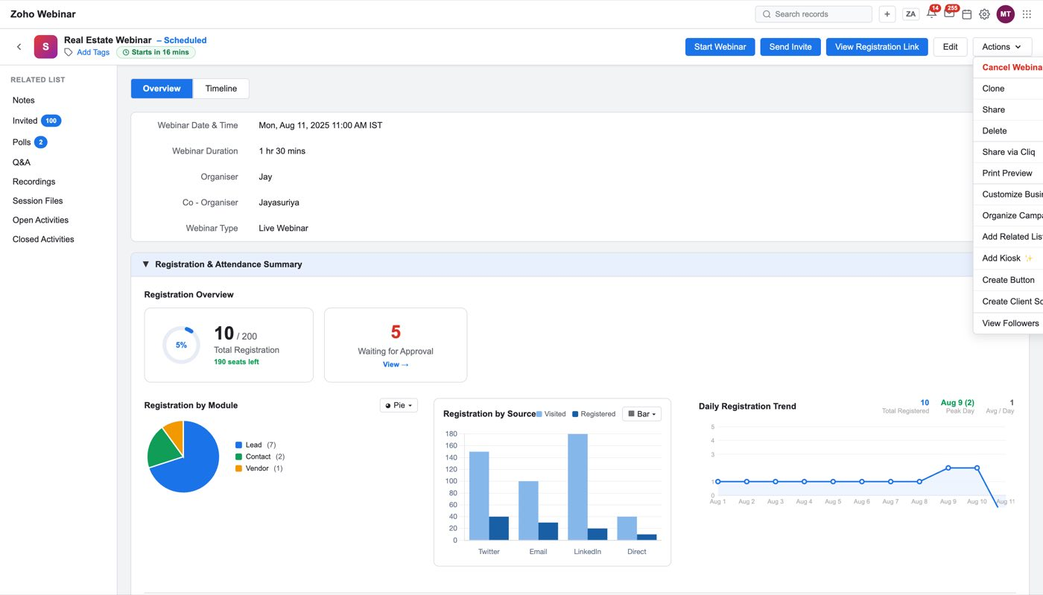
Figure 45 — The Actions menu open on a scheduled webinar
All thirteen items, in order:
# | Item | Notes
1 | Cancel Webinar | shown in red. On a recurrent webinar the label is Cancel and it opens a choice modal (this occurrence / all future). Absent on a completed webinar
2 | Clone
3 | Share
4 | Delete
5 | Share via Cliq
6 | Print Preview
7 | Customize Business Card | standard CRM
8 | Organize Campaign Details | standard CRM
9 | Add Related List | standard CRM
10 | Add Kiosk ✨ | ✨ marks a Zia/AI item
11 | Create Button | standard CRM
12 | Create Client Script ✨
13 | View Followers

Items 7–13 are CRM's standard record actions, inherited because Zoho Webinar is a CRM module. Only item 1 is webinar-specific and only it is conditional.
Note
The cancel item is the only thing in this menu whose label and behaviour change with record state — Cancel Webinar for a one-off, Cancel plus a this-occurrence/all-future modal for a recurrent one, and nothing at all once completed.

---

5. Completed webinar
A webinar whose Webinar Category is Completed Webinar. The record answers a different question now: not "who is coming" but "what did we get".
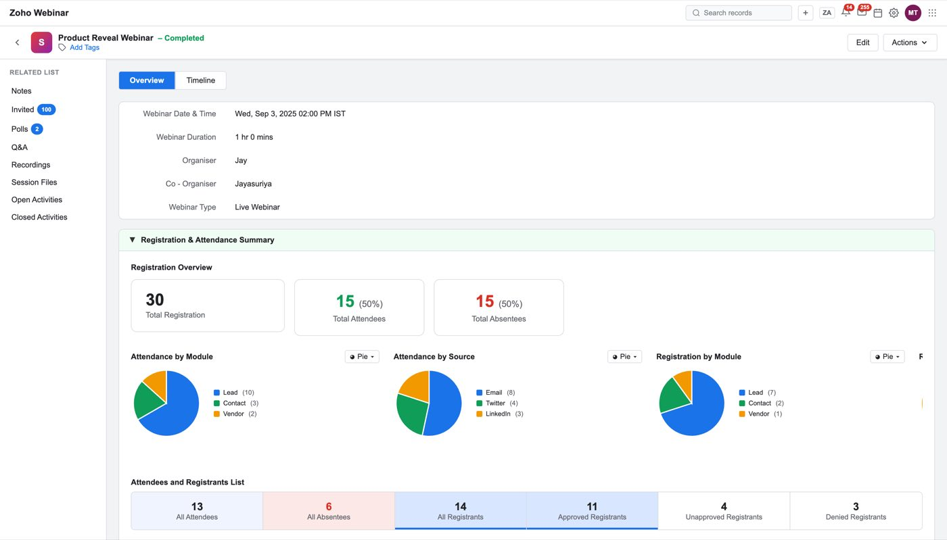
Figure 46 — A completed webinar
What changes in the header: Start Webinar, Send Invite and View Registration Link are gone. Only Edit and Actions remain. The rail is unchanged, and a Webinar Revenue band appears that a scheduled webinar does not have.

5.1 Registration & Attendance Summary
The same band as §4.3, now with the attendance half filled in.
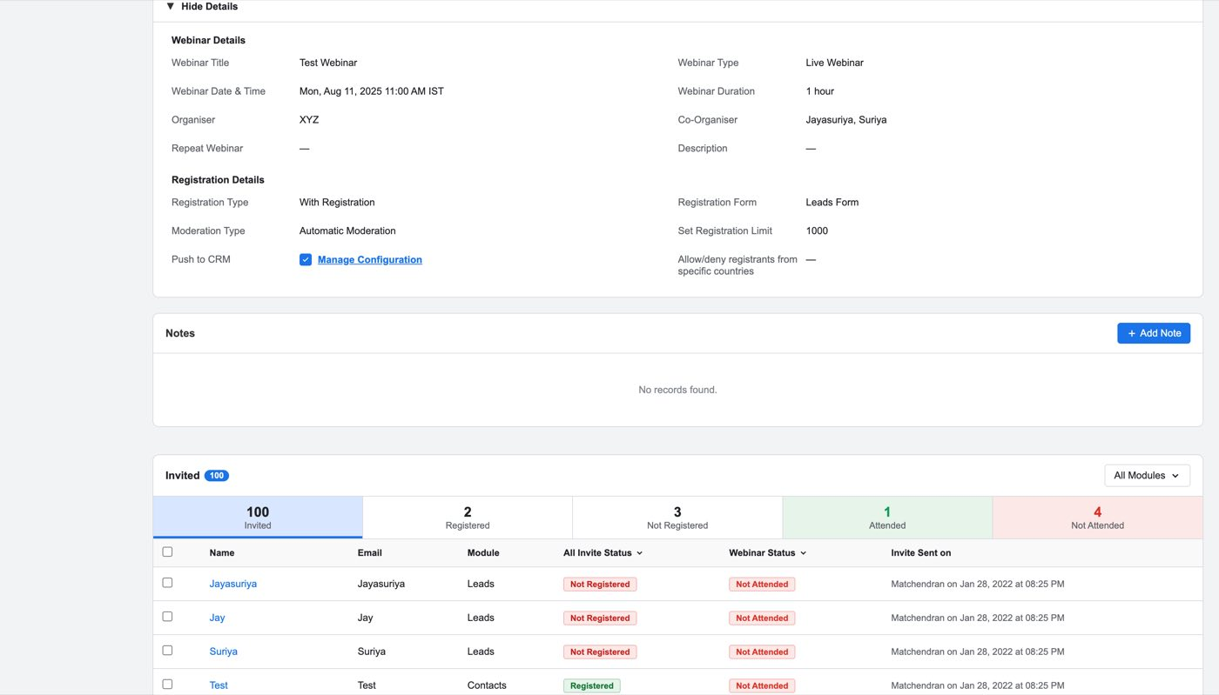
Figure 47 — Registration Overview on a completed webinar — registration, attendees and absentees
Registration Overview carries three figures instead of one:
Figure | Value in the mock
Total Registration | 30
Total Attendees | 15 (50%)
Total Absentees | 15 (50%)

Four charts, where a scheduled webinar had two. Attendance is added alongside registration, so the same cut can be compared before and after:
Chart | Segments
Attendance by Module | Lead (10), Contact (3), Vendor (2)
Attendance by Source | Email (8), Twitter (4), LinkedIn (3)
Registration by Module | Lead (7), Contact (2), Vendor (1)
Registration by Source | Twitter (4), Email (3), LinkedIn (2), Direct (1)

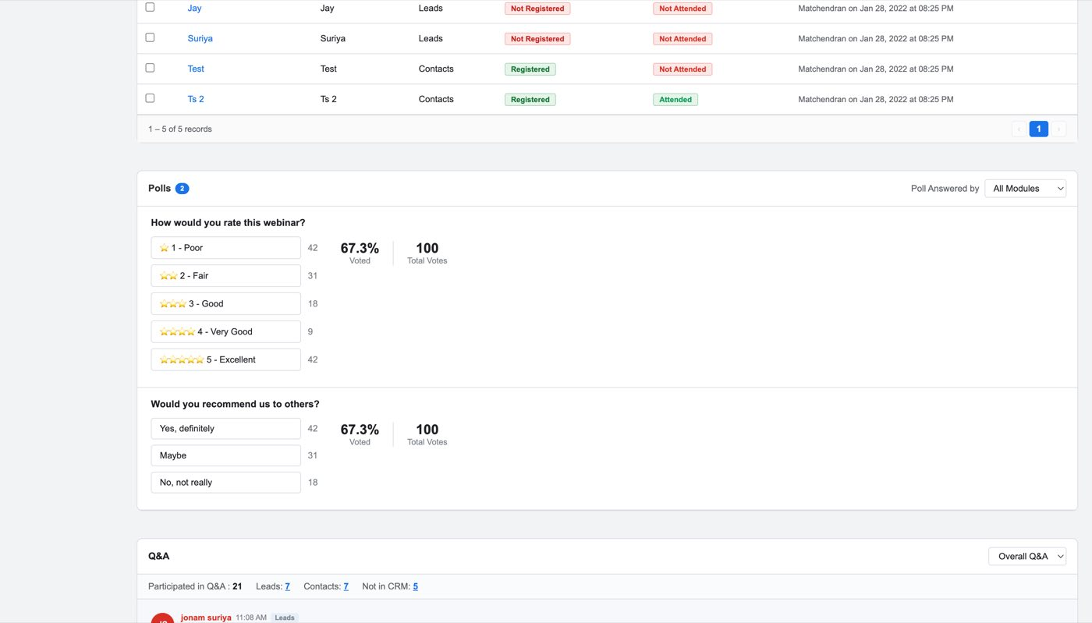
Figure 48 — Registration and Attendance by Source
Attendees and Registrants List — six tabs, each with its own count:
Tab | Count
All Attendees | 13
All Absentees | 6
All Registrants | 14
Approved Registrants | 11
Unapproved Registrants | 4
Denied Registrants | 3

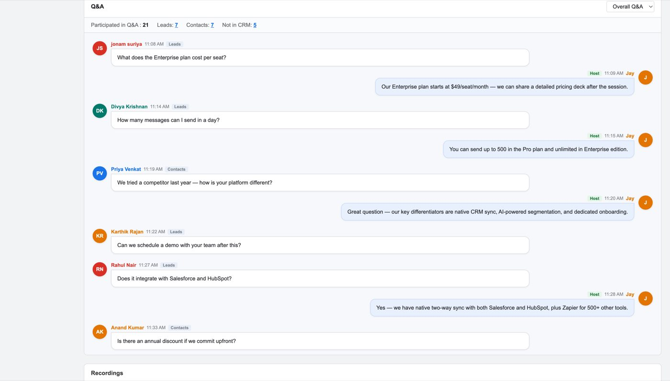
Figure 49 — The Attendees and Registrants list
Columns: Last Name · Email · All Modules · All Sources · Polls · Q&A · Registered Date · Webinar Status
Webinar Status is Attended or Not Attended. Polls is the count of polls that person answered and Q&A is Yes / — — so the list doubles as an engagement ranking, not just an attendance register. A row whose Module is — came from the public link and is not in CRM.
Note
Mock defect — do not reproduce. These numbers do not reconcile. Registration Overview says 30 registered / 15 attended / 15 absent; the tabs say 13 attendees, 6 absentees, 14 registrants; the table paginates "1 – 10 of 11 records"; and the module segments total 15 for attendance and 10 for registration. Build the relationships (attendees + absentees = registrants; segments sum to the total), not these values.

5.2 Webinar Revenue
The band a completed webinar gains, and the reason Webinar Cost (§3.3.2) exists.
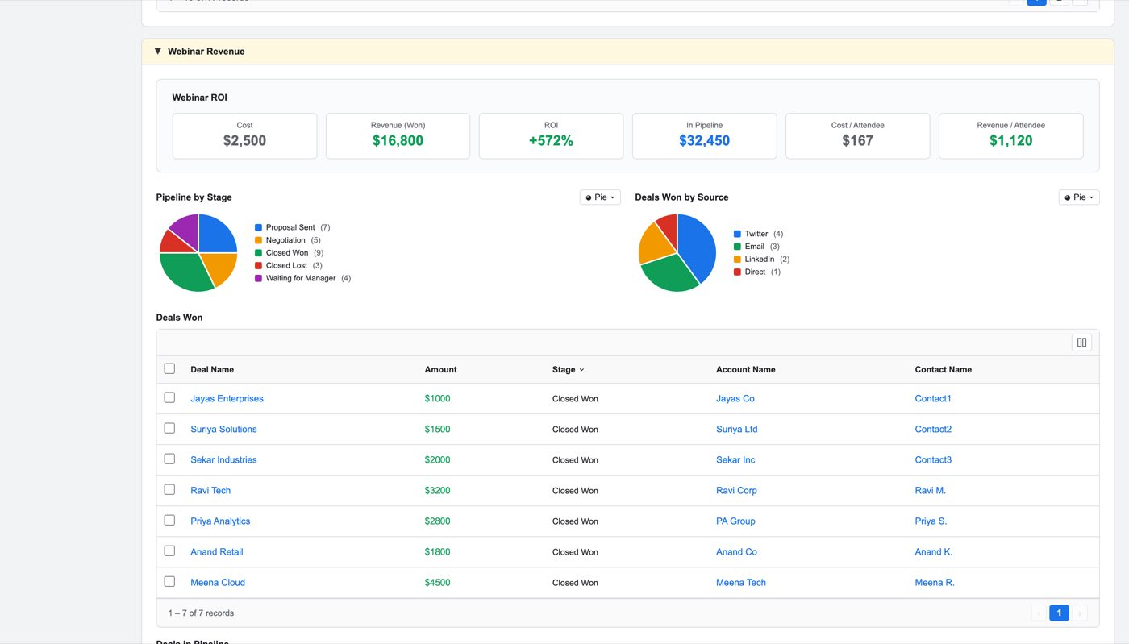
Figure 50 — Webinar ROI, Pipeline by Stage, Deals Won by Source and the Deals Won table
Webinar ROI — six tiles:
Tile | Value | How it is derived
Cost | $2,500 | Webinar Cost from the create form
Revenue (Won) | $16,800 | sum of the Deals Won table
ROI | +572% | (Revenue − Cost) / Cost = (16,800 − 2,500) / 2,500
In Pipeline | $32,450 | sum of open influenced deals
Cost / Attendee | $167 | Cost / attendees = 2,500 / 15
Revenue / Attendee | $1,120 | Revenue / attendees = 16,800 / 15

The arithmetic is consistent — the seven Deals Won rows (1000 + 1500 + 2000 + 3200 + 2800 + 1800 + 4500) total exactly $16,800, and both per-attendee figures divide by 15, the Total Attendees from §5.1. Those formulas are the specification.
Two charts:
- Pipeline by Stage — Proposal Sent (7), Negotiation (5), Closed Won (9),
Closed Lost (3), Waiting for Manager (4)
- Deals Won by Source — Twitter (4), Email (3), LinkedIn (2), Direct (1)
Deals Won table — Deal Name · Amount · Stage · Account Name · Contact Name, 7 records, with Deal Name, Amount, Account Name and Contact Name all rendered as links into their CRM records. Deals in Pipeline follows in the same shape.
Note
Webinar Revenue is collapsed by default and is not in the related-list rail, so it cannot be reached the way Polls or Q&A can. It has to be scrolled to and expanded.

Note
Which deals appear here is decided by the attribution model from §1.2. With Linear, a deal influenced by three webinars contributes a third of its amount to each. The mock does not show the split, so an implementation must decide whether Amount shows the deal's full value or its attributed share — the two give very different ROI.

Open question
Pipeline by Stage shows 9 Closed Won against 7 rows in the Deals Won table. Either the chart counts something wider than the table, or one of them is wrong.

5.3 Invited related list
The record of who was invited from CRM and what became of them — the direct output of §4.1.
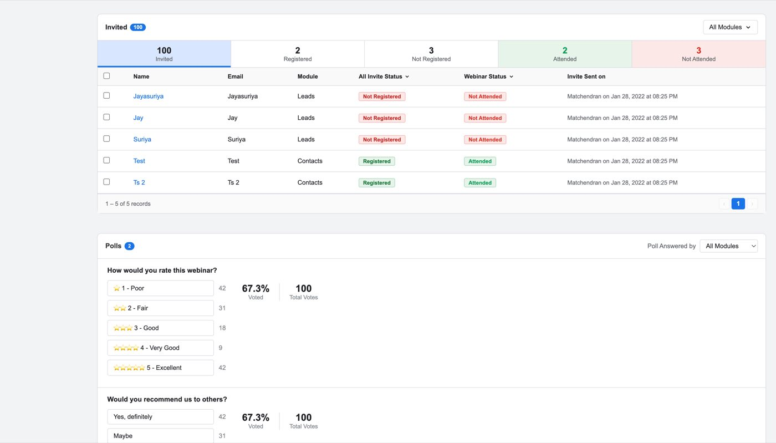
Figure 51 — The Invited related list
Tabs: All Modules · Invited · Registered · Not Registered · Attended · Not Attended — each carrying a count, so the funnel is readable in one line.
Columns:
Column | Example
Name | Jayasuriya
Email | Jayasuriya
Module | Leads / Contacts
All Invite Status | Not Registered / Registered
Webinar Status | Not Attended / Attended
Invite Sent on | Matchendran on Jan 28, 2022 at 08:25 PM

Two separate status fields, and they are not the same thing. All Invite Status tracks the invitation — did this person act on it. Webinar Status tracks the session — did they turn up. A record can be Registered and Not Attended, which is the no-show case the Absentees follow-up email exists for.
Note
This list is the CRM half of the funnel and the Attendees and Registrants list (§5.1) is the webinar half. A person from the public link appears in §5.1 with Module — and never appears here, because they were never invited from CRM. Neither list is a superset of the other.

Note
Mock defect — do not reproduce. "Invite Sent on" shows Matchendran on Jan 28, 2022 — a user and a date unrelated to the rest of the record's 2025 data.

5.4 Polls
The polls written in §4.4, now with answers.
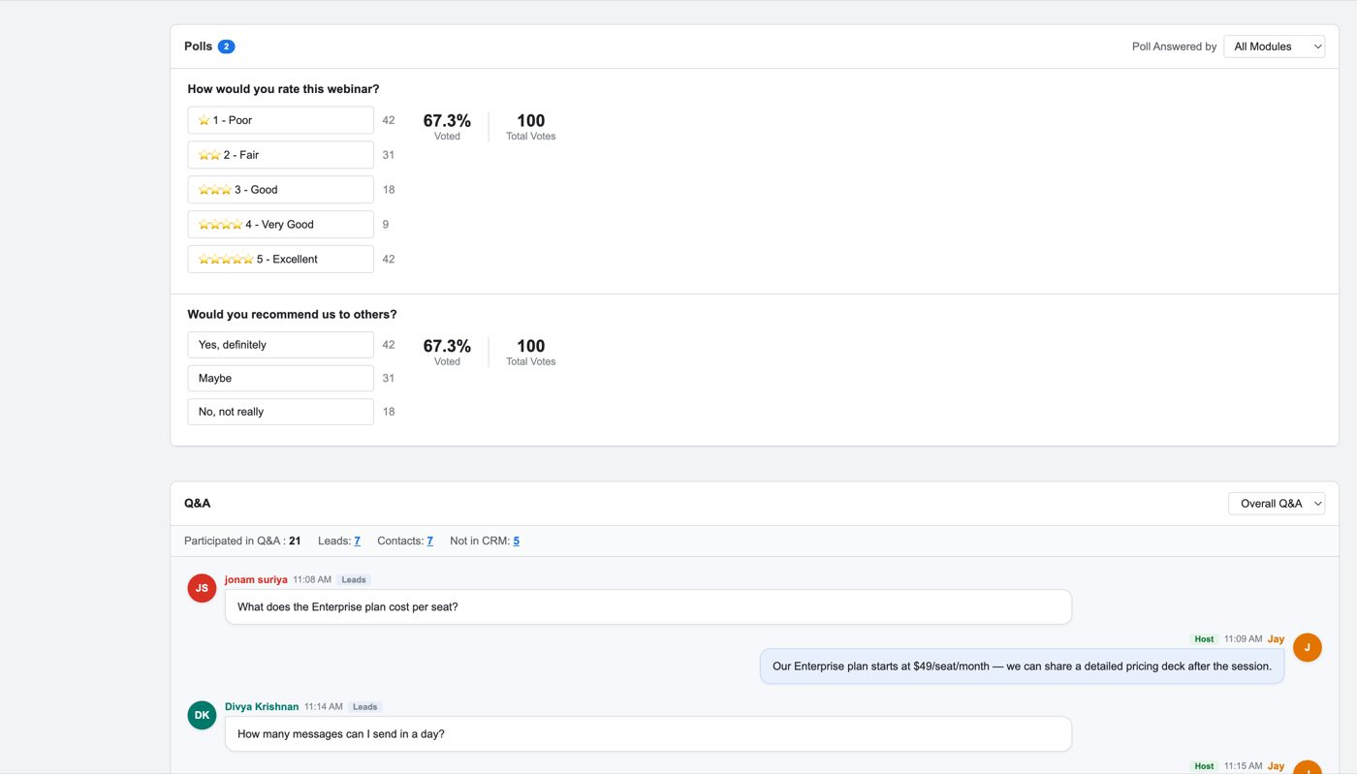
Figure 52 — Poll results on a completed webinar
Poll Answered by tabs cut the results by who answered: All Modules · Leads · Contacts · Vendors · Not in CRM.
Each poll shows its question, every option with its vote count as a bar, then two summary figures:
"How would you rate this webinar?" — ⭐ 1 - Poor · ⭐⭐ 2 - Fair · ⭐⭐⭐ 3 - Good · ⭐⭐⭐⭐ 4 - Very Good · ⭐⭐⭐⭐⭐ 5 - Excellent "Would you recommend us to others?" — Yes, definitely · Maybe · No, not really
Both report `67.3%` Voted and `100` Total Votes.
Clicking through opens the respondent list — Name · Email · Company · Phone · Owner — which is what makes a poll answer actionable: a 5-star rating attached to a named Lead is a follow-up, not a statistic.
Note
The Not in CRM tab is the important one. Poll respondents who arrived from the public link have no CRM record, so their answers cannot be attributed to anyone — unless Push Webinar Registrants to CRM (§3.3.4) was ticked, in which case they will have been created as records.

Open question
Both polls report exactly 67.3% Voted and 100 Total Votes, and the option counts do not sum to 100. Sample data, but the relationship between option counts, Total Votes and % Voted needs defining.

5.5 Q&A
The questions asked during the session, and the host's answers.
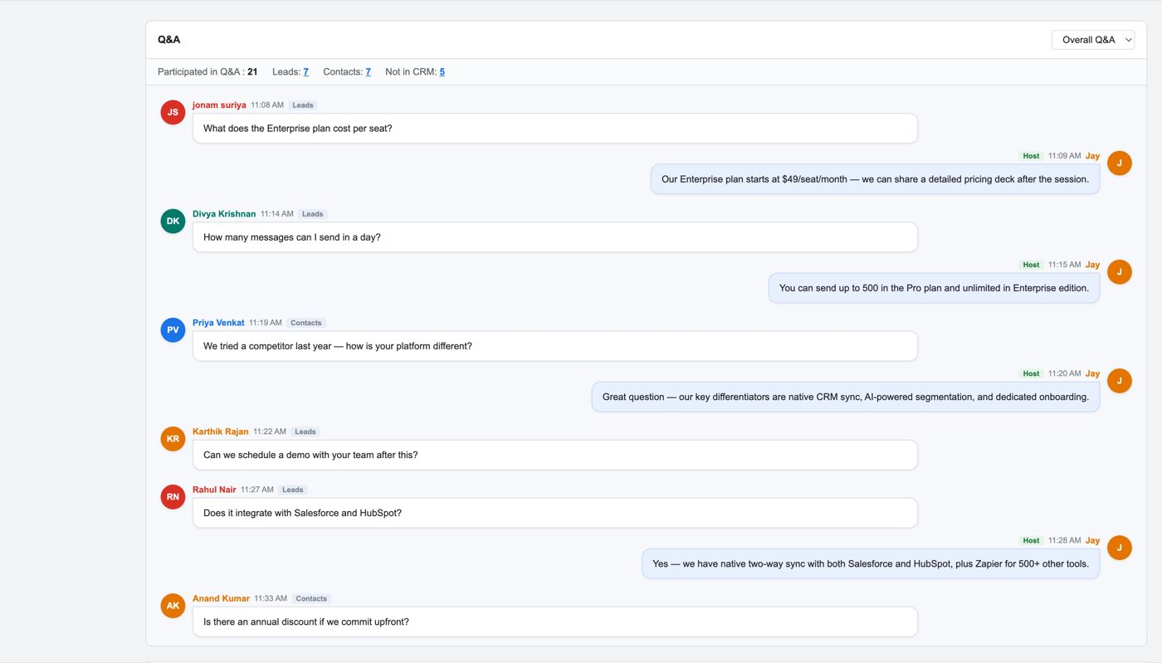
Figure 53 — The Q&A transcript
Tabs: Overall Q&A · Leads · Contacts · Not in CRM — the same cut as Polls.
A participation summary heads the section:
Figure | Value
Participated in Q&A | 21
Leads | 7
Contacts | 7
Not in CRM | 5

The transcript is a threaded conversation, not a table. Each entry carries an avatar with initials, the asker's name, a timestamp, their CRM module as a tag, and the question. A host answer is nested under it, marked Host with the responder's name:
Note
JS jonam suriya · 11:08 AM · Leads "What does the Enterprise plan cost per seat?" J Host · 11:09 AM · Jay "Our Enterprise plan starts at $49/seat/month — we can share a detailed pricing deck after the session."

Not every question has an answer. Two of the seven in the mock are unanswered — which is real behaviour, not a gap: an unanswered question is a follow-up the rep still owes.
Note
The module tag on each question is what makes this worth having in CRM rather than in the webinar tool. "A Lead asked about Salesforce integration" is a sales signal attached to a record; the same sentence in a webinar transcript is not.

Open question
7 + 7 + 5 = 19, but the summary says 21 participated. The tab counts and the total disagree.

Open question
There is no action on a question — no convert-to-task, no assign, no mark-answered. For unanswered questions, which the mock deliberately includes, that is the obvious missing step.

---

Things we still need to decide

Blocking
- Webinar Cost means two different things (§3.3.2). The tooltip calls it what attendees
are charged; the ROI panel treats it as what the webinar cost to run. Cannot build either until this is settled.
- Time Decay is undefined (§1.2). Two of the six attribution models describe a direction
but no decay function and no half-life.
- Attribution and the Deals Won amount (§5.2). Does Amount show a deal's full value or
its attributed share? Linear across three webinars gives an ROI three times apart.

Product
- Should Push Webinar Registrants to CRM default to on? It is the feature that most
justifies the integration and it ships unchecked (§3.3.4).
- Deduplication on push: update, duplicate, or skip when a registrant's email already
matches a record (§3.3.4).
- Re-inviting a record that has already been invited — allowed, resend, or refused
(§4.1).
- Does an on-demand webinar really get no reminders and no follow-ups (§3.2)?
- Send failure is not modelled (§4.1). What happens if Mass Email refuses — no template
chosen, no recipients left after Remove ALL, a send error — has no state.
- Removing every selected record in the picker's step 2 is a dead end: is Next blocked,
or does it return to the record table (§4.1)?
- No invitation templates exist — does Select Template offer inline creation, or does
the flow stall (§4.1)?
- Cancel on re-entry (§1). Cancel is specified as returning to the introduction page,
but for an integration that is already enabled it should arguably return to the enabled panel. Confirm which.
- The three blocking modals have no stated exit (§1) — only the not-an-admin modal's
button is named. Where dismissal lands is unspecified.
- Save on the enabled page (§1) has no success or failure state; the dirty-state bar is
named but its outcome is not.
- Does attribution count attendance or registration (§1.2)?
- What happens to already-invited records when a module is turned off in §1.1?

Engineering
- Attendance Count / Attend. Rate must distinguish "not yet known" from zero — the list
renders —, not 0 (§2).
- The detail page scrolls an inner element, capped at 2820px (scheduled) / 3812px
(completed) (§4).
- Attribution card selection is carried by inline style, not a class (§1.2).
- Webinar Revenue is collapsed by default and absent from the rail (§5.2).
- All drill-downs from summary charts currently return 0 records (§4.3).

Design
- Next does nothing before Add in the Send Invite picker (§4.1) — disable Next, or drop
Add.
- The Actions menu is clipped at the right edge of the viewport in the mock (§4.6).
- The Registration & Attendance Summary band keeps its name on a scheduled webinar where
there is no attendance data (§4.3).
- No back navigation in the setup wizard (§1). Only Cancel and Next exist, yet every
answered step stays on screen with its fields live — so a user can see an earlier answer but has no stated way to return to it.
- No Cancel or discard on the create form (§3) — only Save is modelled.
- Manage Config has no stated exit (§3.3.4) — what closes it, and whether it can be
cancelled, is unspecified.

Assumptions this document makes
- The three account-blocking cases in §1 are driven by a DEMO switcher in the mock; real
behaviour is assumed to come from the user's Zoho Webinar account and CRM role.
- Field lists, types, defaults and options were extracted from the mock's DOM, not
typed. Where a control is custom (Repeat Webinar, Co-Organizer, template slots) the type column says "custom control" rather than guessing a primitive.
- Sample values (names, counts, amounts) are mock data and are quoted only to show shape.

Mock defects — do not reproduce
- §5.1 Registration, attendance and tab counts do not reconcile with each other or with
the table's own pagination.
- §5.5 Q&A tab counts sum to 19 against a stated 21 participants.
- §5.4 Poll option counts do not sum to Total Votes; both polls report identical
figures.
- §5.2 Pipeline by Stage shows 9 Closed Won against 7 rows in Deals Won.
- §5.3 "Invite Sent on" reads Matchendran on Jan 28, 2022, unrelated to the record.
- The registrant list on a webinar whose only channel is Email still carries rows sourced
LinkedIn, Twitter and Direct.
---

Appendix A — every field in the create form
63 fields. Visible is per variant: L = Live + With Registration, W = Live + Without Registration, O = On-Demand. A field not visible in a variant is not rendered at all, not merely disabled.
Field | Type | Req | Default | L | W | O
Webinar title | Text | Yes | (Enter webinar title) | ✓ | ✓ | ✓
Webinar Type | Picklist | No | Live Webinar | ✓ | ✓ | ✓
Webinar Date & Time | Date + time picklist | No | today, 10:00 AM | ✓ | ✓ | ✓
Webinar Duration | Compound picklist | No | 1 hr + 00 min | ✓ | ✓ | —
Video File | File | No | — | — | — | ✓
Webinar Timezone | Picklist | No | (-6) Central | ✓ | ✓ | ✓
Allow video play/pause | Checkbox | No | checked | — | — | ✓
Webinar Owner | Picklist + lookup | No | Rao Priya | ✓ | ✓ | ✓
Organizer | Picklist w/ search | No | Jayasuriya | ✓ | ✓ | ✓
Repeat Webinar | Custom → modal | No | off | ✓ | ✓ | —
Co-Organizer | Custom → panel | No | None | ✓ | ✓ | —
Webinar Cost | Text, $ prefix | No | (0.00) | ✓ | ✓ | ✓
Description | Textarea | No | empty | ✓ | ✓ | ✓
Registration Type | Picklist | No | With Registration | ✓ | ✓ | ✓
Registration Form | Picklist | No | Default Form | ✓ | — | ✓
Customize Registration Page | Picklist | No | Standard Template | ✓ | — | ✓
Moderation Type | Picklist | No | Automatic Moderation | ✓ | — | ✓
Set Registration Limit | Text | No | empty | ✓ | — | ✓
Push Webinar Registrants to CRM | Checkbox + Manage Config | No | unchecked | ✓ | — | ✓
Allow/deny registrants from specific countries | Picklist | No | No Restrictions | ✓ | ✓ | ✓
Select Allowed Countries | Multi-select (revealed) | No | — | ○ | ○ | ○
Allow/Block Specific Domains | Picklist | No | No Restriction | ✓ | — | ✓
Add Allowed Domains | Text (revealed) | No | — | ○ | ○ | ○
Post_Registration Custom Redirection | Text | No | (https://) | ✓ | — | ✓
Post Redirection URL | Text (revealed) | No | — | ○ | ○ | ○
Allow access to join link only through mail | Checkbox | No | checked | ✓ | — | ✓
Allow only authenticated Zoho Users with a Zoho account | Checkbox | No | unchecked | ✓ | ✓ | ✓
Who can Join | Picklist | No | — | — | ✓ | —
Send Confirmation to Registrants | Checkbox | No | checked | ✓ | — | ✓
Confirmation Email Template | Template picker | No | Webinar Confirmation Template | ✓ | — | ✓
Send thank you email to attendees | Checkbox | No | — | — | ✓ | —
Thank You Email Template | Template picker | No | — | — | ✓ | —
Allow attendees to ask questions | Checkbox | No | — | ✓ | ✓ | ✓
Allow anonymous questions | Checkbox | No | — | ✓ | ✓ | —
Show questions to all | Checkbox | No | — | ✓ | ✓ | —
Auto Reply for questions | Checkbox (revealed) | No | — | ○ | ○ | ○
Automatic session recording | Checkbox | No | — | ✓ | ✓ | —
Video recording | Checkbox | No | — | ✓ | ✓ | —
Display attendee list to all | Checkbox | No | — | ✓ | ✓ | —
Use Emoji reactions | Checkbox | No | — | ✓ | ✓ | —
Post webinar Re-direction | Checkbox | No | — | ✓ | ✓ | ✓
1st Reminder | Picklist | No | 15 mins before the webinar | ✓ | — | —
1st Reminder Template | Template picker | No | — | ✓ | — | —
2nd Reminder | Picklist | No | None | ✓ | — | —
2nd Reminder Template | Template picker (revealed) | No | — | ○ | — | —
3rd Reminder | Picklist | No | None | ✓ | — | —
3rd Reminder Template | Template picker (revealed) | No | — | ○ | — | —
Send Follow-up Email to Attendees | Picklist | No | 2 mins after the webinar ends | ✓ | — | —
Send Follow-up Email to Absentees | Picklist | No | 2 mins after the webinar ends | ✓ | — | —
Attendees Follow-up Template | Template picker | No | — | ✓ | — | —
Absentees Follow-up Template | Template picker | No | — | ✓ | — | —
Include Recording for Attendees | Checkbox | No | unchecked | ✓ | — | —
Include Recording for Absentees | Checkbox | No | unchecked | ✓ | — | —

✓ visible · — not rendered · ○ revealed only when its parent field is set

Picklist options, verbatim
Field | Options
Webinar Type | Live Webinar · OnDemand Webinar
Webinar Timezone | (-5) Eastern · (-6) Central · (-7) Mountain · (-8) Pacific · (+0) UTC · (+5:30) IST
Webinar Owner | Rao Priya · Jay Acme · Mark Acme · Suriya
Organizer | Jayasuriya · Morrison Troy
Registration Type | With Registration · Without Registration
Registration Form | Default Form · Real Estate Form · Stock Trading Form · + Create New Form
Customize Registration Page | Standard Template · Custom Created
Moderation Type | Automatic Moderation · Manual Moderation
Allow/deny registrants from specific countries | No Restrictions · Allow registrants from Countries · Block registrants from Countries
Allow/Block Specific Domains | No Restriction · Allow specific email domains · Block specific email domains
1st Reminder | 2 mins · 5 mins · 10 mins · 15 mins · 30 mins · 1 hour · 2 hours · 6 hours · 12 hours · 1 day · 1 week — before the webinar
2nd / 3rd Reminder | None + the same eleven intervals
Send Follow-up to Attendees / Absentees | None · 2 mins · 5 mins · 10 mins · 15 mins · 1 hour · 2 hours · 6 hours · 1 day — after the webinar ends (note: no 30 mins and no 12 hours here, unlike the reminder list)

Integration constants
`IM_MODULES` — Leads · Contacts · Vendors · Donors · Volunteers · Members · Students · Alumni · Partners · Speakers · Referrals · Patients · Subscribers `IM_LOCKED` — Leads · Contacts Attribution models — first · last · linear (default) · increasing · decreasing · position

Where each flow starts, for testing
Flow | Entry
Integration | Setup → Marketplace → Zoho → Zoho Meetings card → For webinars › Set up
Webinar list | Zoho Webinar module in the left rail
Create webinar | List page → Create Webinar
Scheduled webinar | List page → any row with Category Scheduled Webinar
Send Invite | Scheduled webinar → Send Invite
Registration source | Scheduled webinar → View Registration Link
Completed webinar | List page → any row with Category Completed Webinar
Webinar Revenue | Completed webinar → scroll past the attendee list, expand the band

